**CEBU ROOSEVELT MEMORIAL COLLEGES**

San Vicente St., Bogo City, Cebu

**COLLEGE OF COMPUTER STUDIES**

**MEDELLIN NATIONAL HIGH SCHOOL ENROLLMENT SYSTEM**

A PROPOSED CAPSTONE PROJECT PRESENTED

TO THE DEAN OF THE COLLEGE OF COMPUTER STUDIES,

CEBU ROOSEVELT MEMORIAL COLLEGES

­­­­

IN PARTIAL FULFILLMENT OF THE REQUIREMENTS FOR THE

DEGREE OF BACHELOR OF SCIENCE IN INFORMATION TECHNOLOGY

BY:

ERWIN SON

ANJIE LOU OLIVAR

SHERRYBELLE CANAMA



*“College in Name, University in Nature”.*

**JANUARY 2022**

**CEBU ROOSEVELT MEMORIAL COLLEGES**

San Vicente St., Bogo City, Cebu

**COLLEGE OF COMPUTER STUDIES**

**ENDORSEMENT SHEET**

In partial fulfillment of the requirements for the degree of Bachelor of Science in Information Technology, this capstone project entitled “Medellin National High School Online Enrollment System” has been prepared and submitted by Erwin Son, Sherrybelle Canama and Anjie Lou Olivar, and hereby recommended for an oral examination.

**MARJORIE O. RESO**

Adviser

Accepted as partial fulfillment of the requirements for the degree of Bachelor of Science in Information Technology (BSIT).

**JONEL D. GELIG, MBE, DM-HRM**

Dean, College of Computer Studies

**CEBU ROOSEVELT MEMORIAL COLLEGES**

San Vicente St., Bogo City, Cebu

**COLLEGE OF COMPUTER STUDIES**

**APPROVAL SHEET**

Approved by the Panel of Examiners during the Oral Examination with the grade of _________.

**JONEL D. GELIG, MBE, DM-HRM**

Chairman

**VINCENT ISRAEL D. PRIAS**

Member

**LEONARD C. BALABAT**

Member

Accepted and approved in partial fulfillment of the requirements for the degree of Bachelor of Science in Information Technology.

Date:

________

**JONEL D. GELIG, MBE, DM-HRM**

Dean, College of Computer Studies

**ACKNOWLEDGEMENT**

This research study would have not been completed without the help and support of the following to whom the researchers are indebted to in the completion of this study.

First and foremost, to our Heavenly Father who is the source of our strength. He has always been here with us to guide us and give us wisdom to overcome all the obstacles we had encountered through this journey. He is the reason for all of this.

To our beloved dean, Dr. Jonel Gelig, for sharing his knowledge and his useful views about our study. He gave us helpful advices and suggestions that motivated us to give our all for this study.

To our adviser, Ms. Marjorie Reso, for enduring patience in checking our papers and giving corrections. She gave her best to teach us and extended her hand to guide us throughout this study.

To the Medellin National High School, the admin, teachers and enrolling staff, for their cooperation to our research study. They spared us time to give us information we need to complete this study.

To the parents, for giving us emotional and financial support. They have been our inspiration and a constant reminder to give our best and to never give up along the way.

To my co-researchers, who always thought positive in every situation, for having unity, patience and perseverance in completing this research study.

**DEDICATIONS**

Life is not a race. You may not win today but sooner or later, your day will come, not just an ordinary day but could be one of the biggest days in your life where your name will be known by the people. The only thing life means to me, life is all about finding our purposes and doing our missions here in this world. If we are able to do that, that’s what I call, “success”.

This study is dedicated to the only woman I really loved, who supported me all throughout the days. No other than my mother. Thank you for the sacrifices you’ve done for me. You are not just my mother but a hero in my life. I love you so much, mom.

To my brother and sister, thank you for helping me every day. There are purposes why we became siblings, and that is to help each other building our future.

To my friends, thank you for helping me during the times of difficulties. You were always there to help in any means. Thank you for making me feel that I am not alone.

To our adviser, Ms. Marjorie Reso, thank you so much for imparting your knowledge with us. Thank you for doing your best for us to learn. I know how tough our attitudes are, but you really did a great job, ma’am.

To our dean, Dr. Jonel Gelig and to all of the faculty members, thank you for guiding us.

And most especially to our Almighty God, thank you for everything. Thank you so much for the strength for us to accomplish things. Without you, we are nothing. All glory and praise to you God. Thank you so much.

-Son

To start off, I would like to thank and dedicate this study to our Almighty God for being with us through the ups and downs of this journey. He gave us strength, good health and wisdom that helped us fulfill this study. It would be impossible without Him. It’s all for you, God. We can’t thank you enough.

To my parents, whose been my inspiration and motivation to continue and to never give up. Specially to my mom, who never gets tired of reminding me to eat and rest, and to my dad for working so hard.

To my brothers and sisters for always supporting me in any way they can. You’re also one of the reason why I strove so hard for this. Thank you so much, I love you all.

To my classmates, for lifting one another in times of difficulties. To our group leader, for having so much patience and perseverance to finish this study, our sleepless nights have finally paid off.

To our adviser, Ms. Marjorie Reso, this study would not have been successful without your patience and knowledge. Thank you for helping us achieve our dreams and for giving your best to help us overcome every struggle we encounter. We owe it all to you. Thank you so much, ma’am.

To our dean, Dr. Jonel Gelig, and to the rest of CCS faculty, for giving us advices since day one that we’ve been keeping in our sleeves all along. Thank you for imparting your knowledge with us.

I would like to extend my deepest gratitude to the people mentioned above. Thank you so much and God bless.

-Canama

This work is dedicated to my parents and sibling who is always been there for me and gave their untiring support and encouragement for me to keep on going despite all the challenges we’ve been through. They stood by me all these years and loved me unconditionally. They are the ones who taught me to work hard until I succeed.

I would like to thank my partner for the encouragement, love, support and for always believing in me.

To our adviser, Ms. Marjorie Reso, thank you for sharing her knowledge and guiding me throughout this study

Also I dedicate this work to my friends, who helped me in times of need. I want to thank them for their moral support and also for believing in me. This work is also dedicated to my co-researchers, thank you for everything, for the cooperation, for all the knowledge, all of the efforts and sacrifices. Those sacrifices and those sleepless nights were finally paid off. May God bless us all.

And finally, this work is solely dedicated to God Almighty who gives me all the wisdom and the source of my strength upon making this work possible. He always has been there for me, guiding me through ups and down.

-Olivar

TABLE OF CONTENTS

Title page i

Endorsement Sheet ii

Approval Sheet iii

Acknowledgment iv

Dedication v

Table of Contents ix

List of Figures xi

List of Tables xiii

Chapter I

Rationale 1

Statement of the Problem 3

Objectives of the Study 5

Significance of the Study 7

Scope and Limitation 8

Review of Related Literature 9

Research Methodology 20

Research Method 20

Research Respondents 20

Research Evironment 20

Research Instrument 21

Research Procedures 21

Gathering of Data 21

Treatment of Data 21

**Chapter II**

Presentation, Analysis, And Interpretation of Data 23

Requirement Analysis 42

Functional Requirement 42

Non-Functional Requirement 44

Context Diagram 45

Use Case Diagram 46

Event Table 71

Activity Diagram 73

Entity-Relationship Diagram 75

Class Diagram 76

Metadata 77

Design of the Prototype 84

**CHAPTER III**

Summary of Findings 121

Conclusions 123

Recommendations 123

Implementation View of the System 125

Component Diagram 125

Deployment Diagram 126

Cost-Benefit Analysis 127

Bibliography 128

Appendices

Appendix A - Endorsement Letter 130

Appendix B - Questionnaire 132

Appendix C - Work Breakdown Structure 136

Appendix D - Gantt Chart 140

Appendix E - Relevant Source Code 141

Appendix F - Curriculum Vitae150

**List of Tables**

Table 1: Illegible Student’s Information23

Table 2: Misplaced Files24

Table 3: Enrollment Processing Assistance24

Table 4: Common Problems During Manual Enrollment26

Table 5: Updates of the Number of Enrollees27

Table 6: Student Monitoring27

Table 7: Online Enrollment Processes28

Table 8: Problems During Online Registration29

Table 9: Improving Current Enrollment Method30

Table 10: Adopting to the Proposed System31

Table 11: Reaction Towards Manual Enrollment Method32

Table 12: The Travel to Medellin National High School33

Table 13: Time Consumed in Filling Out Forms34

Table 14: Difficulties in Getting Enrollment Forms35

Table 15: Misplaced Enrollment Forms36

Table 16: Faster Online Registration37

Table 17: Less Cost Upon Online Registration38

Table 18: Problems Encountered During Online Registration39

Table 19: Secured Online Registration40

Table 20: Adoption to the Proposed System41

Table 21: Use Case Scenario of Admin Login48

Table 22: Use Case Scenario for Add Student50

Table 23: Use Case Scenario for Update Student52

Table 24: Use Case Scenario for Search Student54

Table 25: Use Case Scenario for Delete Student56

Table 26: Use Case Scenario for Display Student58

Table 27: Use Case Scenario for Add Grade Level and Section60

Table 28: Use Case Scenario for Add Subject62

Table 29: Use Case Scenario for Add Teacher64

Table 30: Use Case Scenario for Filter Student66

Table 31: Use Case Scenario for Register Student68

Table 32: Use Case Scenario for View Subject70

Table 33: Event Table72

Table 34: Enrollment77

Table 35: School Year77

Table 36: Faculty78

Table 37: Level and Section79

Table 38: Student80

Table 39: Programs83

Table 40: Subject83

Table 41: Work Breakdown Structure139

**List of Figures**

Figure 1: Context Diagram of Medellin National High School45

Figure 2: Use Case Diagram of Medellin National High School46

Figure 2.1: Use Case Diagram of Admin Login47

Figure 2.2: Use Case Diagram for Add Student49

Figure 2.3: Use Case Diagram for Update Student51

Figure 2.4: Use Case Diagram for Search Student53

Figure 2.5: Use Case Diagram for Delete Student55

Figure 2.6: Use Case Diagram for Display Student56

Figure 2.7: Use Case Diagram for Add Grade Level and Section59

Figure 2.8: Use Case Diagram for Add Subject61

Figure 2.9: Use Case Diagram for Add Teacher63

Figure 3: Use Case Diagram for Filter Students65

Figure 3.1: Use Case Diagram for Register Student67

Figure 3.2: Use Case Diagram for View Subject69

Figure 4: Activity Diagrams74

Figure 5: Entity-Relationship Diagram75

Figure 6: Class Diagram76

Figure 7: Component Diagram125

Figure 8: Deployment Diagram126

Figure 9: Gantt Chart140

CHAPTER I

**RATIONALE**

Computers have become the most essential tool invented up to this generation. Computers serve as efficient data storage systems and excellent information processors. It can store, manage and organize huge amounts of data. Moreover, it has an ability to complete tasks in just a fraction of second.

Computers are everywhere at work, school and home. The educational system has taken advantage of the technology in teaching and learning, processing data, keeping records, and in its enrollment system.

An Online Enrolment System enables the students to enroll themselves to any of the program they want. The system will allow the students to enroll without going to the campus with the help of the internet. The system records the student’s information in an organized manner. This system stores the data in a secured database.

Medellin National High School is one of the popular public schools in Medellin. Before the pandemic started, Medellin National High School is used a manual enrollment system, with the use of pens and enrolment forms. It caused the slow process of registering students wherein students had to travel to the campus to fill-up the enrolment form. During the pandemic, Medellin National High School used Google Forms for online registration of the students to avoid overcrowding and maintain social distancing. This means that Medellin National High School does not have a computerized enrollment system. The system, the researchers, are proposing will be an enhanced version of the current enrollment system of the school.

In relation to this situation, the researchers have come up with the proposed system “Medellin National High School Online Enrollment System”. Adapting to this technology-based application system will enable the said institution to provide better and more convenient services, making the enrollment process much easier, with lesser effort in a short period of time. Furthermore, the system will reduce the workload of the enrolling staff, who normally have to do all the work. This system is extremely useful in the institution.

**STATEMENT OF THE PROBLEM**

This research focuses on a suitable system that will be implemented at Medellin National High School. This study is intended to answer the problems encountered by the enrolling staff and the students using their manual enrollment before and also adopting online registration for their enrollment facility.

The following statements are problems experienced by the students and enrolling staff during enrollment:

* **Expensive Vehicle Fares**

Not all students live near the school. In this case, students have to travel to come over to the school just to enroll wherein they have to pay for their fare which is costly.

* **Securing enrolment forms is time-consuming**

The students have to get enrollment forms through falling in line, which consumes a lot of time.

* **Unreadable handwriting**

Not all students have good penmanship. Teachers found it difficult to read the handwritten information in the forms because of unreadable handwriting, which may lead to errors and delays in processing the enrollment.

* **Difficulties in updating total number of enrollees**

The enrolling staff find it difficult to update the total number of enrollees during the manual enrollment system, because there are circumstances that students enroll late which causes a change in the number of enrollees. It can cause confusion to enrolling staff in updating the total number of enrollees.

* **Paper consumption during manual enrollment**

Manual enrollment requires a lot of paper for enrollment forms in which students write their information. Due to this, the school allocates budget for papers to be used in printing enrollment forms.

**OBJECTIVES OF THE STUDY**

**General Objective**

The main objective of the study is to help the teachers and enrollees of the Medellin National High School to have an organized flow of enrolment records and easy work. The system will make tasks done faster, more secure and more comprehensive in terms of keeping the student’s information. Having this way of enrolment, the teachers will be able to avoid misplacing records and completion of other tasks are easier. The system will also help the students to enroll themselves easier and eliminate the hassle of going to campus to enroll which may cause slower processes of registration.

**Specific Objectives**

The proposed Medellin National High School Online Enrollment System answers the problems of the teachers and students with regards to enrolment processes which are as follows:

**Admin:**

1. To reduce the manpower needed in facilitating an enrolment process.
2. To record the student’s information upon enrolment.
3. To lessen the time consumed in accessing student’s data.
4. To have a more secure database of storing student’s data.
5. To provide an easy way of searching, updating and saving student’s information details.

**Students**:

1. To enroll themselves easier and faster online with the help of the internet.
2. To eliminate the hassle of the students going to the campus to enroll themselves.

**SIGNIFICANCE OF THE STUDY**

The main purpose of developing this system is to help the staff of Medellin National High School to manage their enrollment process more conveniently. The proposed system plays a significant role to the following:

* **Admin** – The proposed enrolment system will help the admin of Medellin National High School during enrolment period. It’ll help the admin lessen the time in accommodating students in registration. This system helps them to make the other tasks faster and will help the admin in providing more accurate reports.
* **Students** – The students will be able to enroll themselves quickly without going to campus and will lessen the time in registration.
* **Researcher** – This study enhances the researchers on how to create a website. It serves as training on developing the skills of the students to attain more knowledge in gathering and analyzing data.

**SCOPE AND LIMITATION**

This study was conducted at Medellin National High School in Poblacion, Medellin, Cebu. The researchers mainly focused and limited the study on the following.

**Scope**

The proposed online enrolment system covers major processes in the enrolment system of Medellin National High School such as:

* The student can log in and log out.
* The student can register for enrollment.
* The admin can log in and log out.
* The admin can create new student information.
* The admin can update, search, and delete student’s information.
* The admin can view list of students enrolled.
* The admin can filter student’s list by section or grade level.
* The admin can add teacher’s information.
* The admin can add grade level and section.
* The admin can add subjects for every grade level.
* The system can generate total enrollees for the school year.

**Limitation**

The proposed Online Enrolment System for Medellin National High School does not accept online payment.

**REVIEW OF RELATED LITERATURE**

This study is to provide the reader with broad theoretical framework and gaining more ideas about the flow of our study entitled “Medellin National High School Online Enrolment System”.

**1. CAVITE MARITIME INSTITUTE-Online Enrolment System**

**Overview**

The proposed online system was a portal type system that covered the major processes in the enrolment system of Cavite Maritime Institute (CMI) namely: Registration of the current students, class scheduling and sectioning, assessment of fees, file maintenance, report generation (registration form, assessment slip, student master list, and other forms and reports essential to the system). The proposed system included the processing of student’s personal records and the mode of payment that the student would choose.

**Abstract**

The Online Enrolment System was proposed in replacement of the Manual Enrolment System of the institution for it to have an organized flow of transaction and an ease of work especially to the administrators of Cavite Maritime Institute. The study is concerned on how the manual enrolment performs throughout the company’s transaction.

**Features- Background of the study**

* Development and Provision of Maritime Education Services, especially in BS Marine Transportation, BS Marine Engineering, Seafarer Rater Courses (Engine, Steward, and Deck), HRM for Passengers Ships and IMO Model Courses Specification; CHED Policies, Standard, and Guidelines; TESDA Regulations; and MTC Resolutions.
  + - * Development and Provisions of Paramedical, Practical Nursing and Vocational/Technological Courses, in accordance with TESDA TVET Regulations.
      * Provision of Maritime Training and Assessment Services, especially in Basic Safety, Advanced Safety, Tanker man, Watch keeping, Steward/Mess man, allied and Marina Courses, in accordance, TESDA TVET Regulations, MTC Resolution, and Marina Training Regulation.
      * Other course offerings such BS Customs Administration, BS Business Administration Major in Marketing Management, and BS Business Administration Major in Operation Management.

**Technical Support**

A web application or web app is an application that is accessed via the Internet or an Intranet. Web applications are popular due to ubiquity of the client. The ability to update and maintain web applications without distributing and installing software on potentially thousands of client computers are key reasons for their popularity. A significant advantage of building web applications to support a standard browser feature is the ability to perform as specified, regardless of the operating system installed on a given client.[1]

**2. UNIVERSITY OF MARYLAND UNIVERSITY COLLEGE-The Student Enrolment and Course Tracking System Meta-Project**

**Overview**

The main requirement for the Meta-Project was to provide a series of linked projects that would allow the students to become familiar with the background to a specific project in a minimal amount of time. As the students already use the Interactive Registration and Information System (IRIS) at UMUC to register for classes, check out grades, and add and drop classes, they are somewhat familiar with the system. The Meta-Project was designed with this undocumented knowledge in mind, and examines the different aspects of the SECTS during the various parts of the Software Development Life Cycle (SDLC).

**Abstract**

This paper discusses an innovation in teaching the Systems and Software Development Cycle (SDLC) in the Graduate School of Management and Technology at University of Maryland University College. The innovation is a Meta-Project that takes the form of a series of linked projects across the four of classes that cover the SDLC. The benefits that the Meta-Project provides the student with, are a better understanding of the interaction between the phases in the SDLC, and a better ability to cope with the vagueness of the real world.

**Features**

* The system allows the administrator to modify records such as the allocated number per offer no.
* The system allows the administrator to enter a new record into

the system. The administrator can add subjects, curriculum, department, enrolment officer per department, and subject schedules. The enrolment officer can add new entry of a student into the system, add student grades, and add faculty in the department.

* The system allows the administrator to search in the database information of a student, faculty, enrolment officer, and curriculum. The administrator can search for details of the subject schedule. This function allows the administrator to delete a record from the database permanently. When the DELETE button is clicked, the system asks for a confirmation. When the administrator confirms the deletion, the data will be deleted from the database.
* The system is capable of generating unofficial enrolment form containing all the subject schedules enrolled. The system can also generate a student curriculum, list of students enrolled, and list of schedules.

**Technical support**

UMUC offers educational opportunities to students who work full time and wish to increase their skills and knowledge by studying in the evening. One of these opportunities is the chance to earn a Master of Science degree in Computer Systems Management (CSMN). As part of the requirements for the degree, students specialize in one of four tracks or majors. One of these tracks is the Software Development Management (SDM) track. Students in this track take classes in ‘testing’ and ‘maintenance’.[2]

**3. LICEO DE CAGAYAN UNIVERSITY- Online Enrollment System**

**Overview**

The Online Enrollment System was proposed for the enhancement of the current enrollment system of Liceo de Cagayan University. The study aimed at creating a system that would provide another option for enrolling and that would compensate for the school’s lack of manpower and time-consuming system.

**Abstract**

This system uses the dbEnrollment. It contains many tables and stores information such as student’s academic records, secretary’s files and records, class schedules, pre-requisites, subjects, curricula and other essential data needed in the system. The proposed system caters to old, freshmen, transferees and shifters with the following services: subject evaluation, posting of grades, viewing of curriculum, add and update profile.

**Technical support**

The proposed system caters the following services: subject evaluation, posting of grades, viewing of curriculum, add and update profile. It contains many tables and stores information such as student’s academic records, secretary’s files and records, class schedules, pre-requisites, subjects, curricula and others.[3]

**4. CIEVEROSE COLLEGE – Computerized Enrollment System**

**Overview**

Computerized Enrollment system allow students to enroll without any hassle, eliminating or reducing problems with traditional enroll systems, such as long lines, paper forms and troublesome wait lists, Enrollment system is very essential in a school. The school used manual system in recording and retrieving student’s information. On the other hand, registrar’s office also used manual system as a way of recording and retrieving student information. Above the researcher’s observation, human interventions will highly involve in this type of system. As a result, this may involve errors and duplication of data resulting troubles in organization.

**Abstract**

The proposed enhancement of the existing Enrollment System for Cieverose College is going to be a Computerized Enrollment System. The proposed system will decrease the number of manpower, space, and time needed or enrollment. The system will not only give the school the benefit of being able to cut down the money and time spent for the enrollment. The proposed system facilitates in keeping track of the records, transactions, and other activities of the students regarding the enrollment. The system generated reports needed by the faculty and the students like the Official Receipt, Certificate of Registration, and the Student Master List. The Student Information Sheet, Registration Form, are going to be available computerized where it could be submitted in the same manner.

**Features**

* It covers the registration system, it can only add, save, edit and delete student records. It has two portals for the student who can add and save data.
* For Admin they have a total access to the system they can add, save data, edit, delete and print student record.

**Technical Support**

* Computerized Enrollment System in Visual Basic

We all know that visual basic will only run on windows platform. This is version of the system which will only run on windows operating system. The database is MS access or MySQL.

* Web or Online Enrollment System

An online application that will run on any operating system.  The system is a browser-based application that runs on a browser (chrome, Firefox, safari, etc.). PHP and MySQL are the development tools used.[4]

**5. St. JUDE PARISH SCHOOL – Enrollment System**

**Overview**

The propose Enrollment System for St. Jude Parish School is to planned to provide a better system that will serve as a more reliable tool in registering and enrolling students in the school. The proposed software has an ability to assess the enrollee’s records, manage and organize school’s information of the student. The user interface provides ease through its organized interface and functionality. The proposed system will speed up the process of the manual transaction of the cashier and the enrollee, reducing the possibility of the user to commit a human error, make it easy to keep track of all records and generate a reliable result, the users will consume less amount of time through computerized system rather than working manually.

**Abstract**

Enrollment System is commonly used for registering, assessing, billing and scheduling of students. Saint Jude Parish School is an educational institute that was founded in the year 1990. This school has implemented K-12 educational system and because of this, the enrollment system has been outdated. The enrollment regarding the additional programs will be handled manually. The main problem of this research is that the manual process of the school. Due to the advancement of technology, lack of computerization is a waste of time and effort. Based on Chris joseph, doing a manual process has high chances of human error. The staffs might record mistaken data or duplicate the records.

Features

* The system will only be use by the school beneficiary.
* The system will follow school protocol transactions.
* The system has the ability to alter information if necessary.
* The system will be dynamic and flexible.
* The payment transaction will be just cash and check.
* The system will auto-assign the section of the student but It can also be altered by the user.

**Technical Support**

With this research we aim to provide an enrollment system for the school beneficiary. In this study the system will help manage, record and update data that has been input on it. Through this, the system will provide an easy to learn program that will be more suitable for users. Gathered information about the enrolled students will be kept in the database.[5]

**RESEARCH METHODOLOGY**

This section of the research discusses the research environment, research instruments, research method used by the researchers, data gathering procedures, and the statistical treatment used.

**Research Method**

The researchers used an online survey method for the students and teachers with the use of Google Forms. The sample population was taken from the 10% of the total population of students and teachers. The researchers also conducted one-on-one interview with the principal of Medellin National High School. The aforementioned are the primary tools used in gathering data.

**Research Respondents**

The total number of respondents is one hundred sixty-one (161) which included five (5) teachers and one hundred fifty-six (156) current students.

**Research Environment**

The research was conducted at Medellin National High School at Poblacion, Medellin, Cebu.

The institution is currently being managed by Mrs. Elizabeth D. Arreglo along with her office staff. It offers two tracks of specialization in Senior High School Department, such as:

* Academic Track offers General Academic Strand (GAS) and Accountancy, Business and Management (ABM);
* Technical-Vocational-Livelihood (TVL) Track - Information and Communication Technology (ICT).

**Research Instrument**

The researchers used the descriptive research method consisting of two activities.

1. The researchers made questionnaires intended for the staff and students of Medellin National High School to evaluate the institution of the common problems that they have encountered. The questionnaires are made to gather data / information needed for the study.
2. The researchers also conducted one-on-one interview/s within Medellin National High School administration to gather additional knowledge and information needed by the researchers.

**Research Procedures**

**Gathering of Data**. An endorsement letter was sent to Dr. Jonel D. Gelig and Ms. Marjorie Reso requesting for permission to conduct a study in Medellin National High School.

A letter was forwarded to the administrators of Medellin National High School requesting that we, the researchers, be allowed to conduct the study and interview the staff regarding the enrolment process of their institution.

**Treatment of Data**. The researchers prepared questionnaires that were handed out to one hundred sixty-one (161) respondents. After achieving the target population for every year level, the researchers tallied, analyzed, compiled and interpreted the data using the scale of choice in the survey. The results of the interpretation were the basis for the recommendation and conclusion of this study.

The formula used in getting the percentage is:

Let N = the total number of responses

f = the frequency or the number of occurrences of the responses

For students:

(f/N)*100

For teachers:

(f/N)*100

**CHAPTER II**

**PRESENTATION, ANALYSIS AND INTERPRETATION OF DATA**

This chapter focuses on the presentation, analysis and interpretation of data. The following are the answers of the survey conducted to the students and teachers of Medellin National High School.

**RESULT PERCENTAGE FROM THE RESEARCH RESPONDENTS**

**Administration**

**N=5**

**Table 1**

**Illegible Student’s Information**

|  |  |  |
| --- | --- | --- |
| Question: In processing enrolments manually, have you experienced difficulty in reading student’s information due to their penmanship? | **f** | **%** |
| Always | 0 | 0.00 |
| Sometimes | 3 | 60.00 |
| Never | 2 | 40.00 |
| **Total** | **5** | **100.00** |

Most of the teachers sometimes misinterpret student's information due to student’s penmanship and 40.00 of them haven’t experienced any. In viewing this sense, it can be stated that they find it hard to understand the handwriting of the students in their enrollment form.

**Table 2**

**Misplaced Files**

|  |  |  |
| --- | --- | --- |
| Question: Have you experienced losing or misplacing student’s enrollment form? | **f** | **%** |
| Always | 0 | 0.00 |
| Sometimes | 4 | 80.00 |
| Never | 1 | 20.00 |
| **Total** | **5** | **100.00** |

Since manual method uses paper for student’s enrollment, sometimes it's hard for them to manage all the forms at once.

Table 2 shows 80.00 of teachers sometimes experience losing or misplacing student’s enrollment form and 20.00 of them haven’t experience. It indicates that teachers sometimes lose or misplace student’s form.

**Table 3**

**Enrolment Processing Assistance**

|  |  |  |
| --- | --- | --- |
| Question: Do you find it difficult to correct the errors in the student’s enrolment form using manual enrolment process? | **f** | **%** |
| Strongly Agree | 1 | 20.00 |
| Agree | 3 | 60.00 |
| Disagree | 1 | 20.00 |
| Strongly Disagree | 0 | 0.00 |
| **Total** | **5** | **100.00** |

Table 3 shows that 80.00 of the teachers agreed that it’s difficult to correct errors in student’s information using manual enrolment and 20.00 disagreed. Formal papers such as student's record must be kept neat and clean as much as possible.

**Table 4**

**Common Problems During Manual Enrolment**

The choices in this question are checkboxes and are ranked according to the number of frequencies of the answers of the respondents since there were multiple answers done by every respondent.

|  |  |  |
| --- | --- | --- |
| Question: As you use the traditional or the manual method of enrolment, what are the common problems you have experienced and encountered? | **f** | **Rank** |
| Inaccurate input of student’s information | 1 | 4 |
| Takes long time to process | 4 | 1 |
| Redundant process of the student’s enrolment | 2 | 3 |
| All of the above | 3 | 2 |
| **Total** | **9** |  |

The table above shows that most of the teachers find it time consuming in processing enrollments using manual method, while some answered redundant process of the student’s enrolment, the other one answered inaccurate input of student’s information, while 3 of them answered all of the above.

In relation to this, manual enrollment method requires more man power to process multiple enrollees at once.

**Table 5**

**Updates of the Number of Enrollees**

|  |  |  |
| --- | --- | --- |
| Question: Is it hard for you to get or update the total number of enrollees you processed manually? | **f** | **%** |
| Yes | 4 | 80.00 |
| No | 1 | 20.00 |
| **Total** | **5** | **100.00** |

As observed, it's hard to count multiple enrollment forms at once that may lead to miscalculation of total enrollees. The table shows that most of the teachers find it hard to get or update the total number of enrollees processed manually, while 20.00 of them answered no.

Therefore, teachers find it hard to update the total number of enrollees manually.

**Table 6**

**Student Monitoring**

|  |  |  |
| --- | --- | --- |
| Question: Is it easier to find the student’s record online than doing it manually? | **f** | **%** |
| Yes | 4 | 80.00 |
| No | 1 | 20.00 |
| **Total** | **5** | **100.00** |

Computerized enrollment process can easily locate a student’s record with the use of search function.

As reflected in table 6, majority of the teachers said that they can easily find student’s record online and 20.00 of them answered no.

**Table 7**

**Online Enrollment Processes**

|  |  |  |
| --- | --- | --- |
| Question: As you accommodate enrollees, do you think it is easier to process enrolments online? | **f** | **%** |
| Strongly Agree | 2 | 40.00 |
| Agree | 3 | 60.00 |
| Disagree | 0 | 0.00 |
| Strongly Disagree | 0 | 0.00 |
| **Total** | **5** | **100.00** |

Processing enrollments with the use of technology requires less man power with less time consumed.

Table 7 indicates that processing enrolments online is easier than doing it manually as agreed by the teachers.

**Table 8**

**Problems During Online Registration**

|  |  |  |
| --- | --- | --- |
| Question: Does the students or parents have any problems with regards to registering online? | **f** | **%** |
| Yes | 1 | 20.00 |
| No | 4 | 80.00 |
| **Total** | **5** | **100.00** |

Most students prefer enrolling online and doing it in their homes to save money spent for fare and to stay safe from this ongoing pandemic.

Therefore, majority of the teachers answered that students or parents did not address any problems about the online registration, but there are some that experienced a parent addressing problems of online registration.

**Table 9**

**Improving Current Enrollment Method**

|  |  |  |
| --- | --- | --- |
| Question: Are you willing to improve your current enrolment method for a better one? | **f** | **%** |
| Strongly Agree | 2 | 20.00 |
| Agree | 3 | 60.00 |
| Disagree | 0 | 0.00 |
| Strongly Disagree | 0 | 0.00 |
| **Total** | **5** | **100.00** |

Medellin N ational High School currently does not have their own enrollment system and only uses the Google Forms for student’s registration.

The result establishes the fact that teachers are in favor of improving the current enrolment method.

**Table 10**

**Adopting to the Proposed System**

|  |  |  |
| --- | --- | --- |
| Question: Are you willing to adopt to a new and convenient way in processing your enrollment? | **f** | **%** |
| Strongly Agree | 1 | 20.00 |
| Agree | 4 | 80.00 |
| Disagree | 0 | 0.00 |
| Strongly Disagree | 0 | 0.00 |
| **Total** | **5** | **100.00** |

With the result in Table 9, it indicates that the teachers are in favor of improving their current enrollment method, so the researchers came up with the idea of proposing an enhanced enrollment system for the said institution.

Therefore, Table 10 indicates that majority of the teachers are in favor in adopting to our proposed system which is the Medellin National High School Online Enrollment System.

**Student**

**N=156**

**Table 11**

**Reaction towards Manual Enrolment Method**

|  |  |  |
| --- | --- | --- |
| Question: During the enrolment process, is it hassle for you to fill out forms manually? | **f** | **%** |
| Strongly Agree | 14 | 8.97 |
| Agree | 70 | 44.87 |
| Disagree | 67 | 42.95 |
| Strongly Disagree | 5 | 3.21 |
| **Total** | **156** | **100.00** |

Most of the students agreed that they find it hassle to fill out forms manually because it really takes time to do it. Some students said that it’s not a hassle for them.

Furthermore, enrollment forms may contain erasures done by the enrollees due to mistakes that will lead delays to the enrolling staff in completing the information needed stated in the enrollment forms.

**Table 12**

**The Travel to Medellin National High School**

|  |  |  |
| --- | --- | --- |
| Question: Is it costly for you to come over to Medellin National High School just to enroll? | **f** | **%** |
| Strongly Agree | 18 | 11.54 |
| Agree | 78 | 50.00 |
| Disagree | 55 | 35.25 |
| Strongly Disagree | 5 | 3.21 |
| **Total** | **156** | **100.00** |

Most of the students agreed that it’s costly for them to travel to school just to enroll, but some of them disagreed.

Coming over to Medellin Nation High School is costly to majority of the students due to different locations and some of them are far from the school so they have to travel just to enroll.

**Table 13**

**Time Consumed in Filling Out Forms**

|  |  |  |
| --- | --- | --- |
| Question: As you fill out forms manually, is it time consuming? | **f** | **%** |
| Strongly Agree | 13 | 8.33 |
| Agree | 72 | 46.16 |
| Disagree | 62 | 39.74 |
| Strongly Disagree | 9 | 5.77 |
| **Total** | **156** | **100.00** |

Greater number of students agreed that filling out forms manually is time consuming, and lesser number of students disagreed.

Filling out forms manually may lead to erasures and makes the enrollment forms look dirty that causes confusion to enrolling staff in reading their enrollment forms.

**Table 14**

**Difficulties in Getting Enrollment Forms**

|  |  |  |
| --- | --- | --- |
| Question: During the manual enrolment process, do you find it difficult to get enrolment forms? | **f** | **%** |
| Strongly Agree | 12 | 7.69 |
| Agree | 62 | 39.74 |
| Disagree | 78 | 50.00 |
| Strongly Disagree | 4 | 2.57 |
| **Total** | **156** | **100.00** |

Most of the students did not experience difficulties in getting enrollment forms while some of the students found it difficult to get forms, but some of them experienced difficulties.

Furthermore, one of the factors that makes it difficult for the students to get enrollment form is that they have to fall in line in large number of enrollees who are also getting enrollment forms.

**Table 15**

**Misplaced Enrollment Forms**

|  |  |  |
| --- | --- | --- |
| Question: Have you experienced losing your enrolment form? | **f** | **%** |
| Yes | 29 | 18.59 |
| No | 127 | 81.41 |
| **Total** | **156** | **100.00** |

As the respective advisers for every year level checks the enrollment forms of the students, some of it were lost due to places where the forms are hidden. Majority of the students haven’t experienced losing their enrolment forms, but some have experienced.

**Table 16**

**Faster Online Registration**

|  |  |  |
| --- | --- | --- |
| Question: Does using online registration makes the enrollment faster? | **f** | **%** |
| Strongly Agree | 38 | 24.36 |
| Agree | 101 | 64.74 |
| Disagree | 16 | 10.26 |
| Strongly Disagree | 1 | 0.64 |
| **Total** | **156** | **100.00** |

Students don’t need to go to the school just to enroll and fall in line in a large number of enrollees that will lead to delays in filling out the enrollment forms.

Most of the students agreed that online registration makes the enrollment faster and some of them disagreed.

**Table 17**

**Less Cost Upon Online Registration**

|  |  |  |
| --- | --- | --- |
| Question: Online registration lessens money cost upon enrolling at school. | **f** | **%** |
| Strongly Agree | 32 | 20.51 |
| Agree | 90 | 57.69 |
| Disagree | 28 | 17.95 |
| Strongly Disagree | 6 | 3.85 |
| **Total** | **156** | **100.00** |

Students don’t need to go to the school for they only need a smartphone or a personal computer and a stable internet to access and fill out the enrolment form online.

As a result, most of the students agreed that online registration lessens the money cost of enrolling to school, but some of them disagreed to it.

**Table 18**

**Problems Encountered During Online Registration**

|  |  |  |
| --- | --- | --- |
| Question: Have you experienced problems in registering online? | **f** | **%** |
| Yes | 90 | 57.69 |
| No | 66 | 42.31 |
| **Total** | **156** | **100.00** |

Registering online may become a problem with some of the student don’t have their own gadget while some is struggling with online registration due to poor internet speed.

Therefore, majority of the students have experienced problems in online registration, and some of them said that they haven’t.

**Table 19**

**Secured Online Registration**

|  |  |  |
| --- | --- | --- |
| Question: Do you think registering online is secured? | **f** | **%** |
| Strongly Agree | 24 | 15.39 |
| Agree | 109 | 69.87 |
| Disagree | 21 | 13.46 |
| Strongly Disagree | 2 | 1.28 |
| **Total** | **156** | **100.00** |

Students believe that their enrollment form will be more secured in a database instead of hiding it to cabinets wherein anyone could access without authorization and can be a threat to student’s confidential information.

Therefore, majority of the student’s agreed that online registration is secured, but some of them disagreed.

**Table 20**

**Adoption to the Proposed System**

|  |  |  |
| --- | --- | --- |
| Question: Do you wish for Medellin National High School to have an own online enrollment system where you register online? | **f** | **%** |
| Strongly Agree | 39 | 25.00 |
| Agree | 107 | 68.59 |
| Disagree | 10 | 6.41 |
| Strongly Disagree | 0 | 0.00 |
| **Total** | **156** | **100.00** |

Students wished for Medellin National High School to have their own online enrollment system to adopt with online registration as the yearly enrollment starts for them to lessen the man power needed in processing their enrollment.

Most of the students wished for the school to have their own online enrollment system, but some of them disagreed. The result in table 20 concludes that the students want the school to have an online enrollment system.

**REQUIREMENT ANALYSIS**

**Functional Requirements**

These are requirements that refers to the activity or processes a system’s capability to perform.

**Inputs**

The system is capable of accepting the following inputs:

* Log in
* Username
* Password
* Student’s Information
* Last name
* First name
* Middle name
* Address
* Birthdate
* Age
* Gender
* Mobile
* Guardian name
* Guardian contact
* Guardian address
* Student Stand
* Grade Level
* Teacher’s information
* Last Name
* First Name
* Middle Name
* Grade Level and Section
* Grade Level
* Section
* Teacher
* Subject
* Grade Level
* Subject

**Processes**

The system is also capable of performing the following:

* The system can register students.
* The system can save the students information.
* The system can add grade level and section.
* The system can generate total enrollees for the school year.
* The system can filter student’s list by section or grade level.
* The system can add subjects in every year level.
* The system can also perform the following features:
* Update student’s information
* Search student’s information
* View student’s information
* Delete student’s information

**Outputs**

The system displays the following information:

* List of students
* Total number of enrollees
* Grade level and section with adviser
* Subject

**Non- Functional requirements**

These are the requirements of the system other than the activities that the system performs.

**Technical:**

* The system is capable of running in any type of web browser.

**Usability:** The system’s functions are easy to learn and remember. It provides functions that enables user to enroll and register students. The fields in student’s information is being required to ensure that all the fields will be filled out.

**Maintainability:** To keep the system in running in condition for the coming years it must be maintained annually. The system should be maintained by a developer to protect the system’s data.

**Reliability:** The system can consistently enroll students and generate total number of enrollees.

**Security:** Username and password are validated upon accessing the system and the password is encrypted.

**CONTEXT DIAGRAM**

Context Diagramis a diagram which is used in systems design to represent the external factors that interact with the system.

**Admin**

**Student**

* Student’s list
* Teacher’s list
* Total number of enrollees
* su
* Account
* Admin session
* Student information
* Teacher information
* Grade Level and Section
* Subject
* Student’s Grade Level and Section
* Student’s Adviser
* Student’s subject
* Student’s registration
* Student’s session

**Figure 1**

**Context Diagram of Medellin National High School Online Enrollment System**

**USE CASE DIAGRAM**

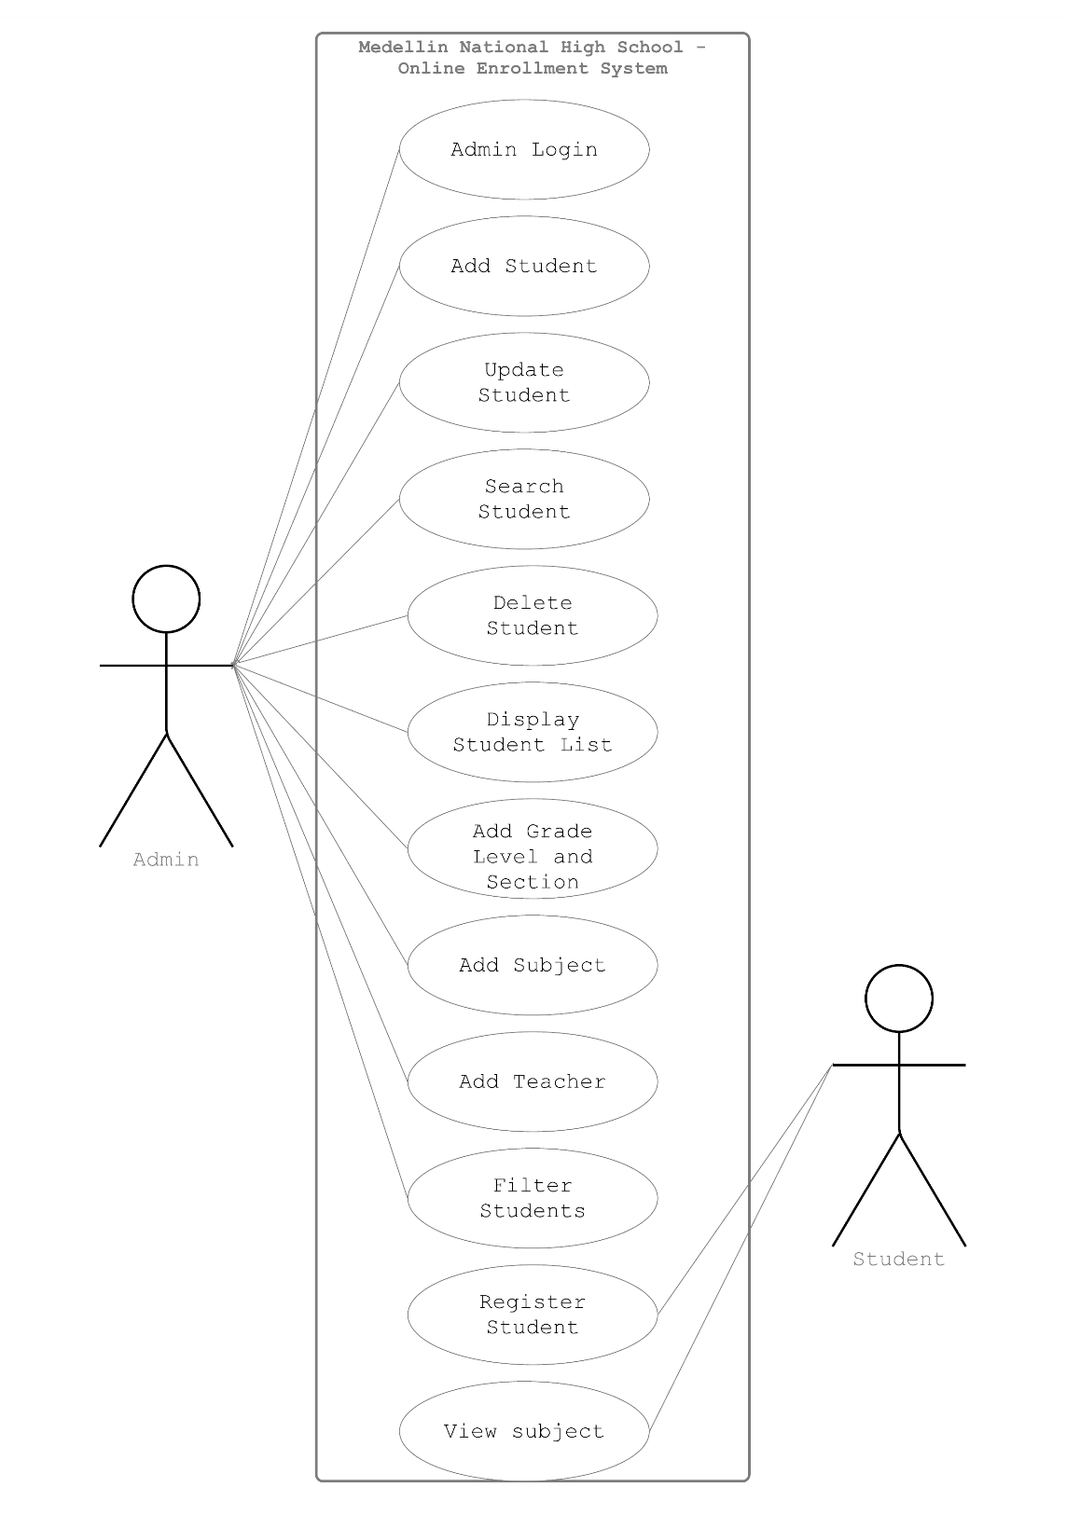Use Case Diagramis a graphical that summarizes the info about the actors and use cases.

**Figure 2**

**Use Case Diagram for Medellin National High School – Online Enrollment System**

**Figure 2.1**

**Use case diagram of Admin Login**

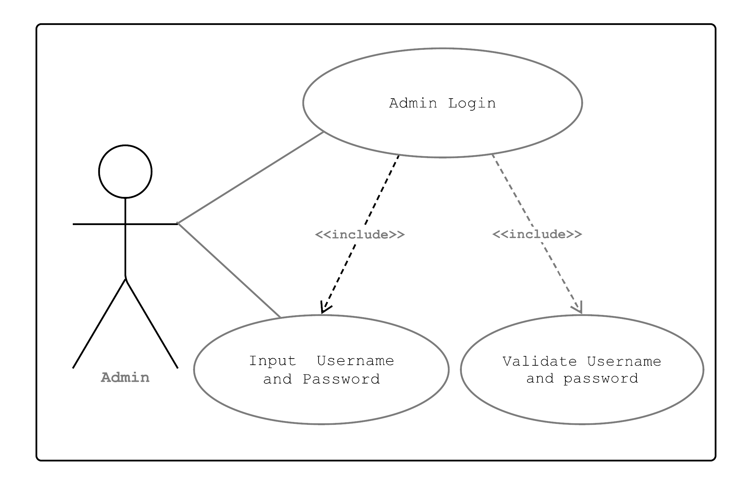

|  |  |
| --- | --- |
| Use Case Name: | Admin Login |
| Actor(s): | Admin |
| Description: | The admin wants to login. |
| Triggering Event: | To access the system. |
| Trigger Type: | External  Temporal |
| **Steps Performed (Main Path)** | **Information Type:** |
| 1. Login form is displayed. | Login Form |
| 1. Admin logs in using the username and password. | userID, Password |
| 1. Admin account is read and password is verified. | Admin Record, userID, Password |
| 1. Login confirmation is displayed. | Admin page form |
| Pre-condition: | The username and password must be correct. |
| Post-condition: | Login successfully. |
| Assumptions: | The admin must have an account. |

**Table 21**

**Use case scenario of Admin Login**

**Figure 2.2**

**Use Case Diagram for Add Student**

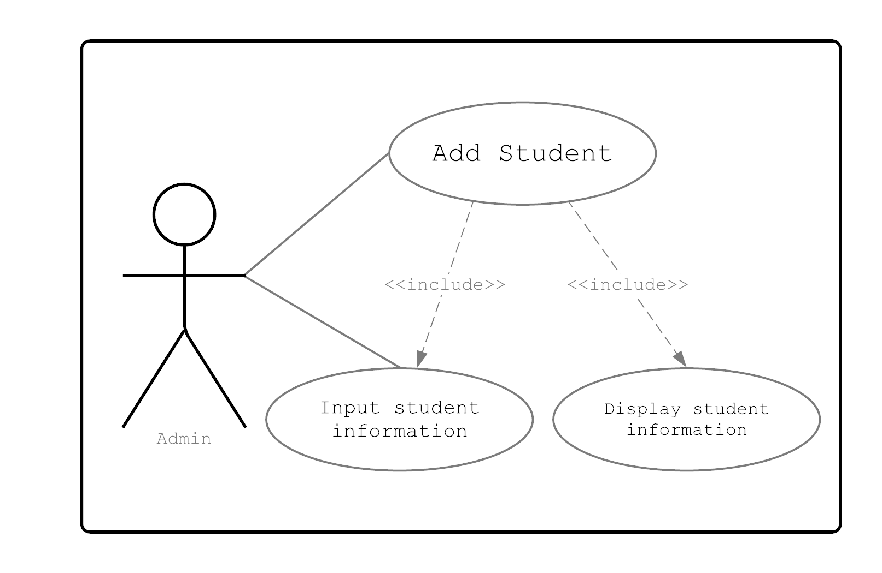

|  |  |
| --- | --- |
| Use Case Name: | Add student |
| Actor(s): | Admin |
| Description: | The admin wants to add new student information. |
| Triggering Event: | To enroll new students. |
| Trigger Type: | External  Temporal |
| **Steps Performed (Main Path)** | **Information Type:** |
| 1. Add student form is displayed. | Student form |
| 1. Admin enters student information. | Student form, student information |
| 1. Admin saves new student information. | Student Information, Save button |
| 1. Confirmation for newly added information is displayed. | Confirmation message |
| Pre-condition: | The student must have fill out the registration form. |
| Post-condition: | New student is successfully added. |
| Assumptions: | Students must have registered. |

**Table 22**

**Use Case Scenario for Add Student**

**Figure 2.3**

**Use Case Diagram for Update Student**

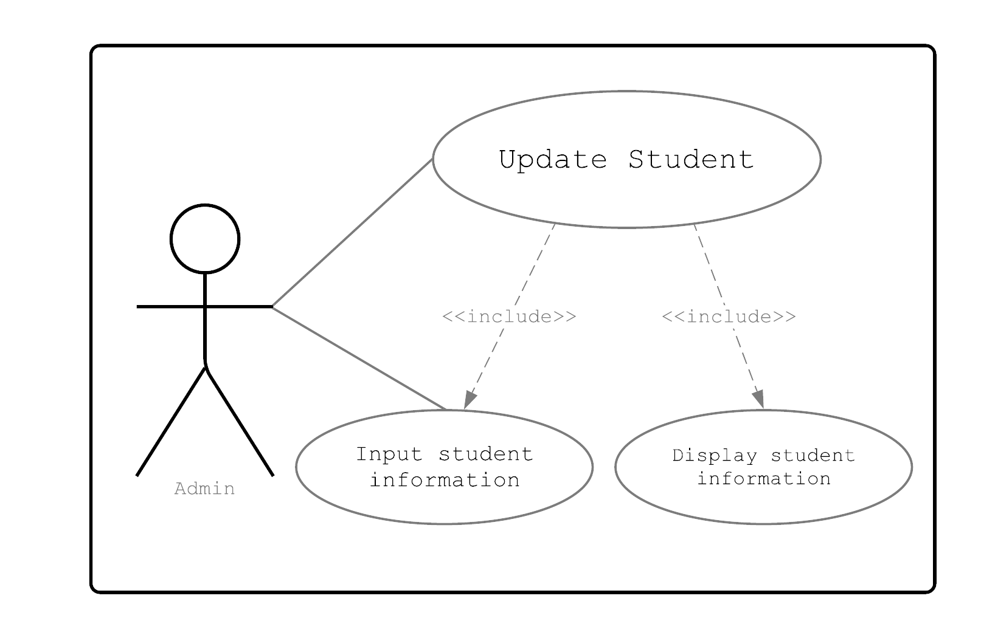

|  |  |
| --- | --- |
| Use Case Name: | Update student |
| Actor(s): | Admin |
| Description: | The admin wants update student information. |
| Triggering Event: | To change student information. |
| Trigger Type: | Temporal  External |
| **Steps Performed (Main Path)** | **Information Type:** |
| 1. Display update form | Update form |
| 1. Admin edits the student information. | Student information |
| 1. Admin saves the changes. | Save button |
| 1. Confirmation for update is displayed. | Confirmation message |
| Pre-condition: | There must be an existing information saved. |
| Post-condition: | Updated information is displayed. |
| Assumptions: | Student must be enrolled. |

**Table 23**

**Use Case Scenario for Update Student**

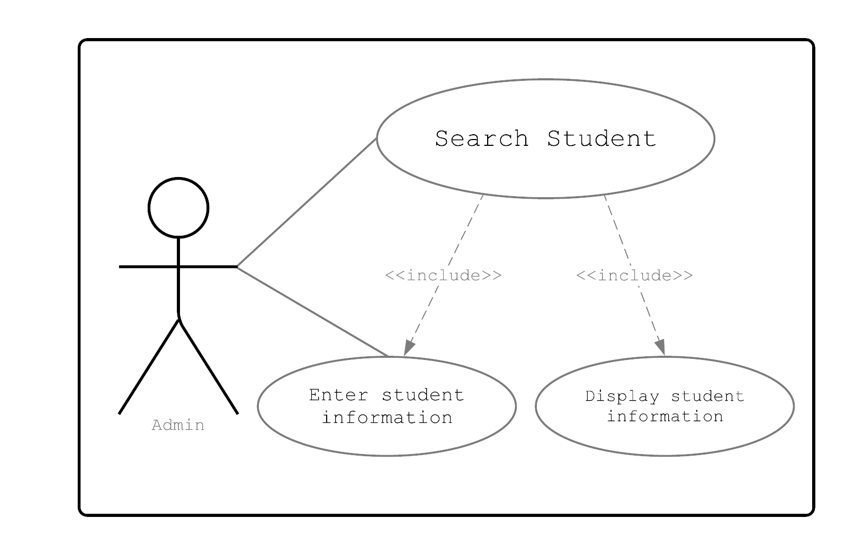

**Figure 2.4**

**Use Case Diagram for Search Student**

|  |  |
| --- | --- |
| Use Case Name: | Search student |
| Actor(s): | Admin |
| Description: | The admin wants to search students. |
| Triggering Event: | To find students information. |
| Trigger Type: | Temporal  External |
| **Steps Performed (Main Path)** | **Information Type:** |
| 1. Admin goes to search bar. | Search bar |
| 1. Admin enters the student information that they want to find. | Student information |
| 1. Student information is displayed. | Student list |
| Pre-condition: | Admin must have information to be searched. |
| Post-condition: | The system displays the student information searched. |
| Assumptions: | Admin must have list of students |

**Table 24**

**Use Case Scenario for Search Student**

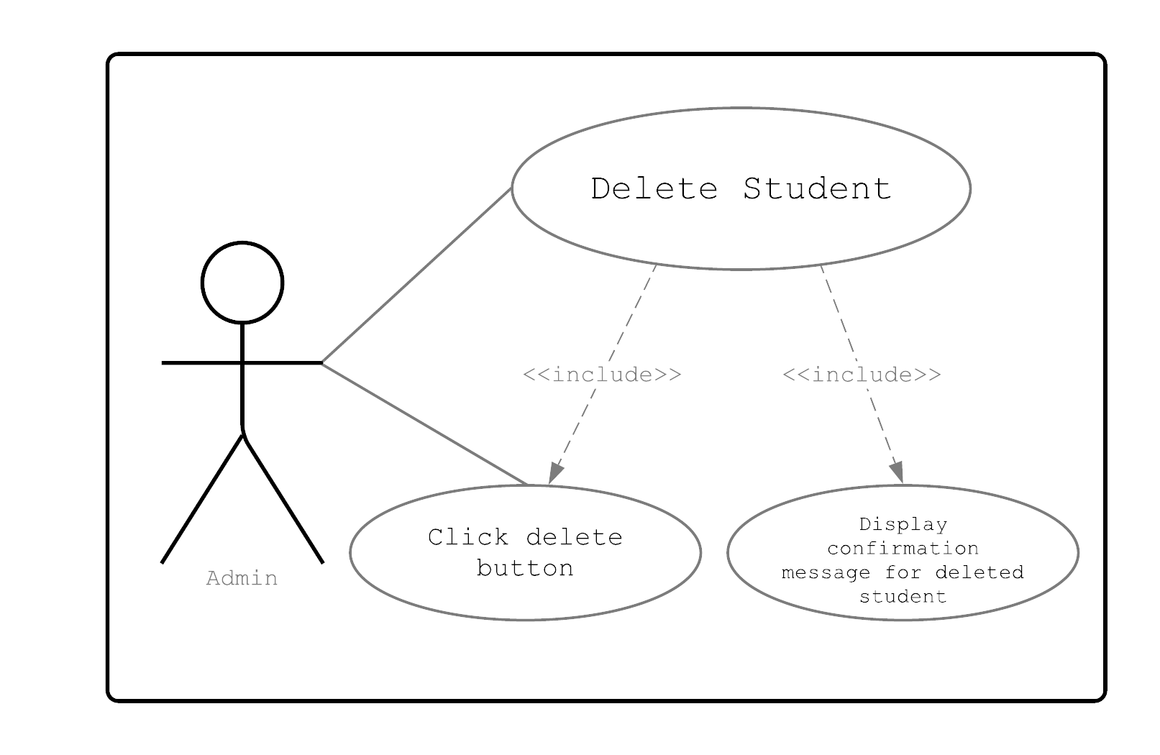

**Figure 2.5**

**Use Case Diagram for Delete Student**

|  |  |
| --- | --- |
| Use Case Name: | Delete student |
| Actor(s): | Admin |
| Description: | The admin wants to delete student information. |
| Triggering Event: | Double entry of students information. |
| Trigger Type: | Temporal  External |
| **Steps Performed (Main Path)** | **Information Type:** |
| 1. Admin views the student information to be deleted. | Student information form |
| 1. Admin deletes the information. | Delete button |
| 1. Confirmation for deleted student is displayed. | Confirmation message |
| Pre-condition: | Check for double entry students. |
| Post-condition: | The system displays updated student list. |
| Assumptions: | Admin must have list of students. |

**Table 25**

**Use Case Scenario for Delete Student**

**Figure 2.6**

**Use Case Diagram for Display Student**

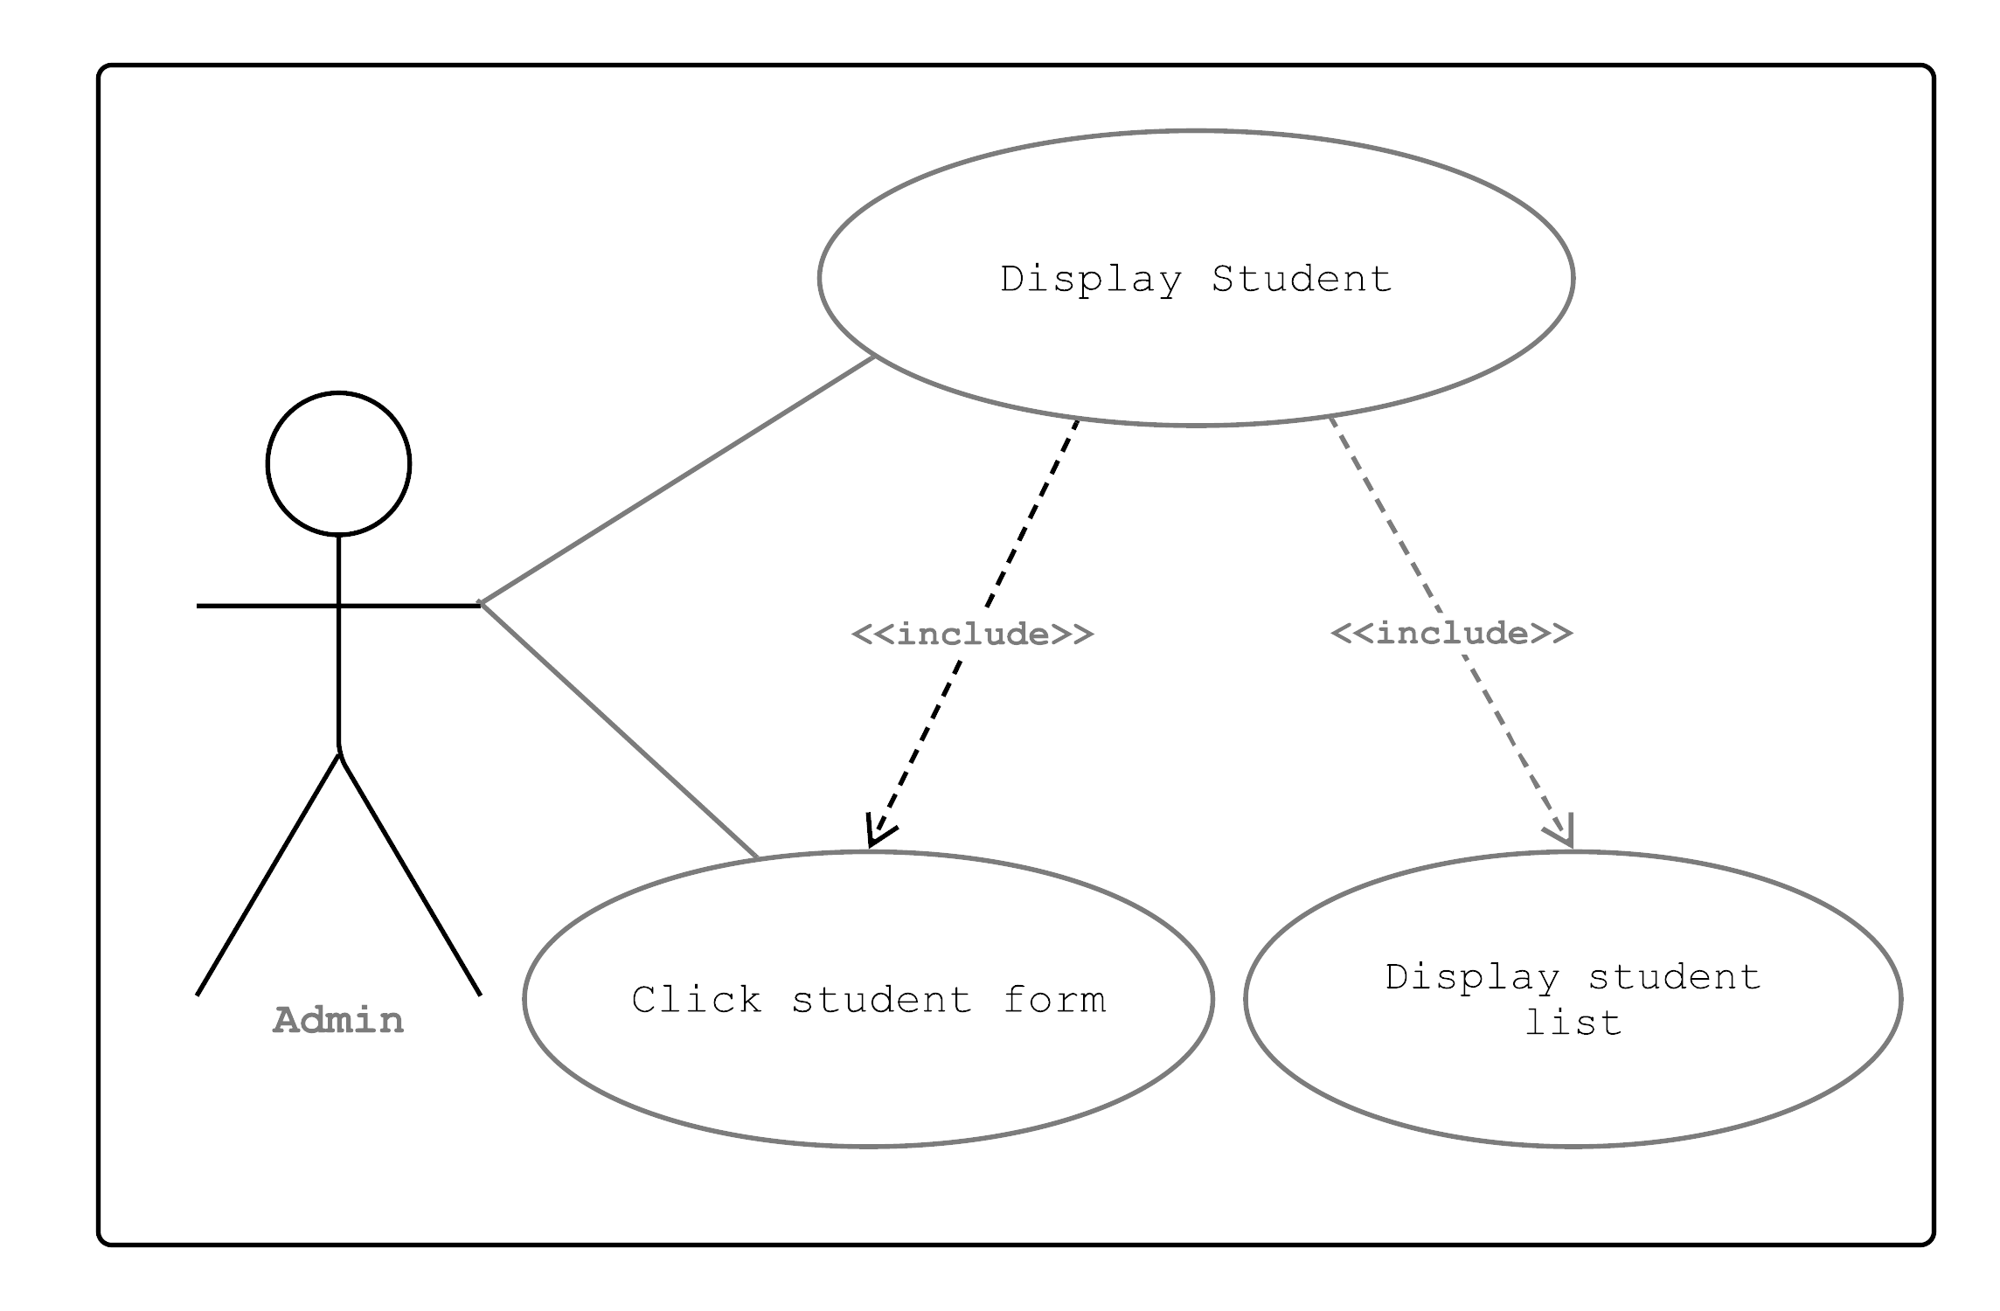

**Figure 2.6**

**Use Case Diagram for Display Student**

|  |  |
| --- | --- |
| Use Case Name: | Display student |
| Actor(s): | Admin |
| Description: | The admin wants to display student information. |
| Triggering Event: | To view enrolled students. |
| Trigger Type: | Temporal  External |
| **Steps Performed (Main Path)** | **Information Type:** |
| 1. Display student list | Students list |
| 1. Display student information | Student form |
| Pre-condition: | Admin must have list of enrolled students |
| Post-condition: | The system displays student information. |
| Assumptions: | Admin must have enrolled students |

**Table 26**

**Use Case Scenario for Display Student**

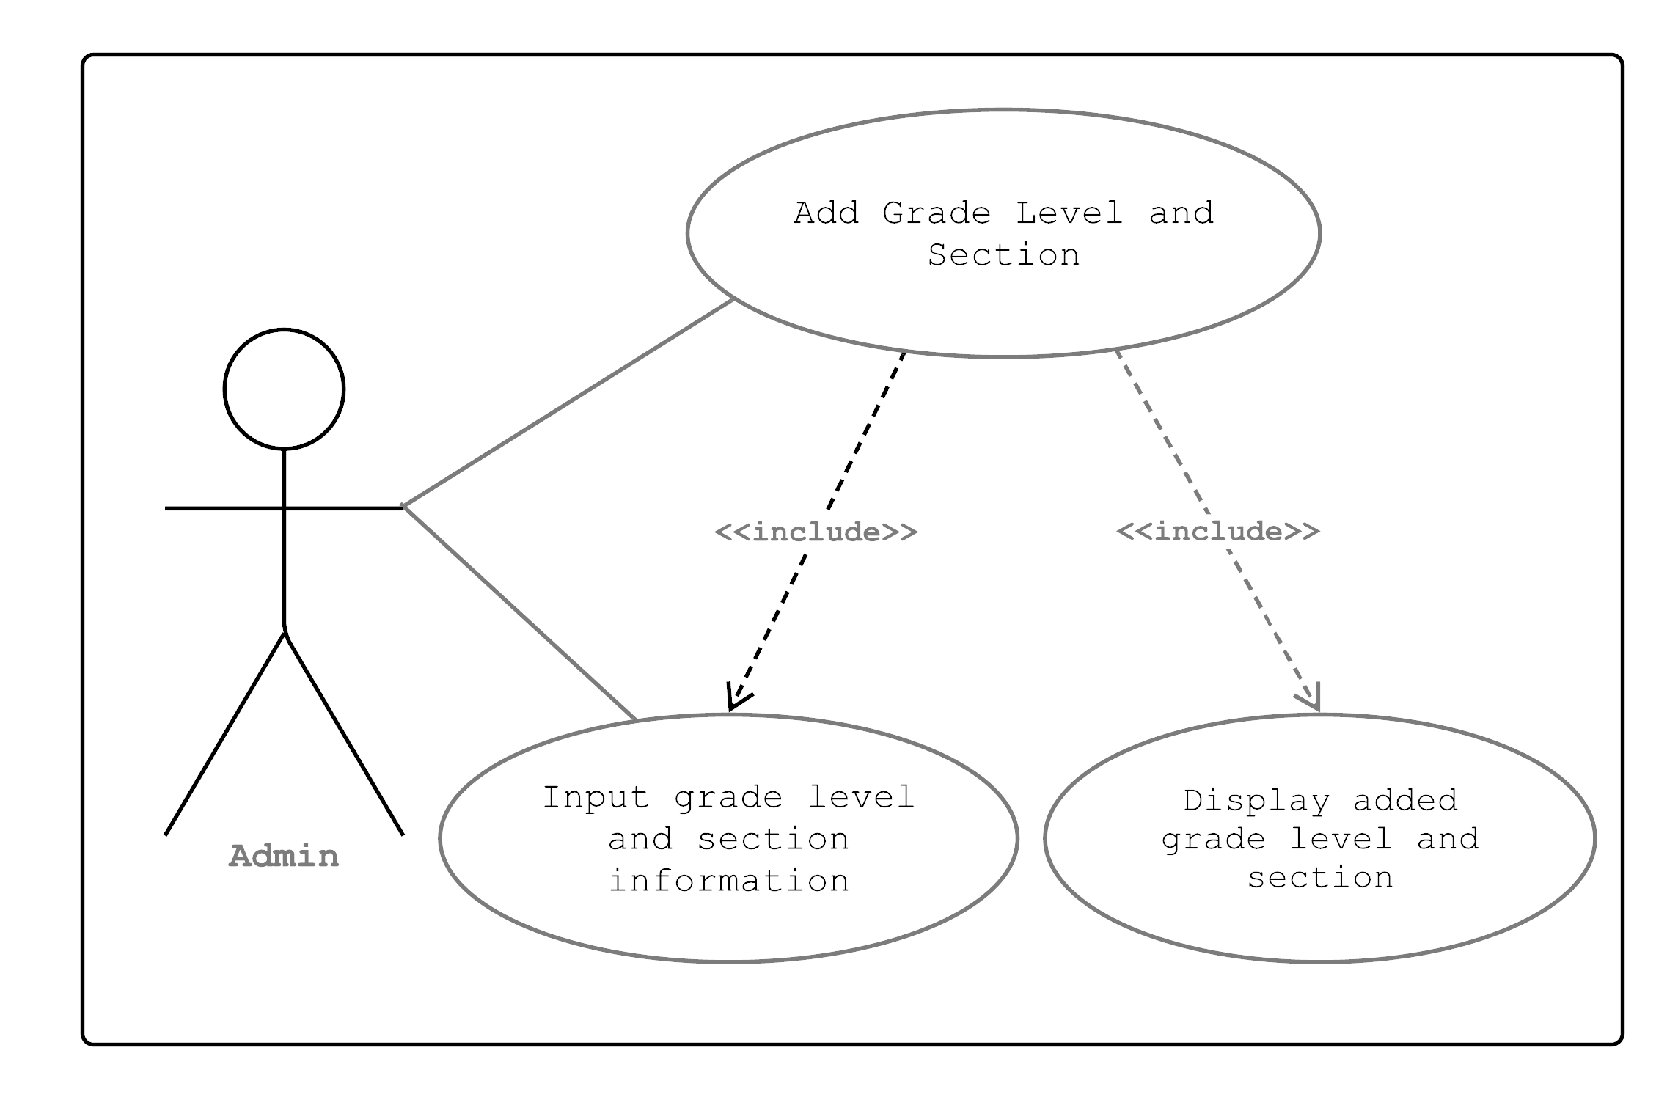

**Figure 2.7**

**Use Case Diagram for Add Grade Level and Section**

|  |  |
| --- | --- |
| Use Case Name: | Add Grade Level and Section |
| Actor(s): | Admin |
| Description: | The admin wants add new grade level and new section. |
| Triggering Event: | To assign grade level and section to students. |
| Trigger Type: | Temporal  External |
| **Steps Performed (Main Path)** | **Information Type:** |
| 1. Input grade level | Level and section form |
| 1. Input section name | Level and section form |
| 1. Assign teacher | Level and section form |
| 1. Click save button | Level and section form |
| Pre-condition: | Admin must have list enrolled students. |
| Post-condition: | The system displays list of grade level with corresponding section and teacher. |
| Assumptions: | Admin must have enrolled students |

**Table 27**

**Use Case Scenario for Add Grade Level and Section**

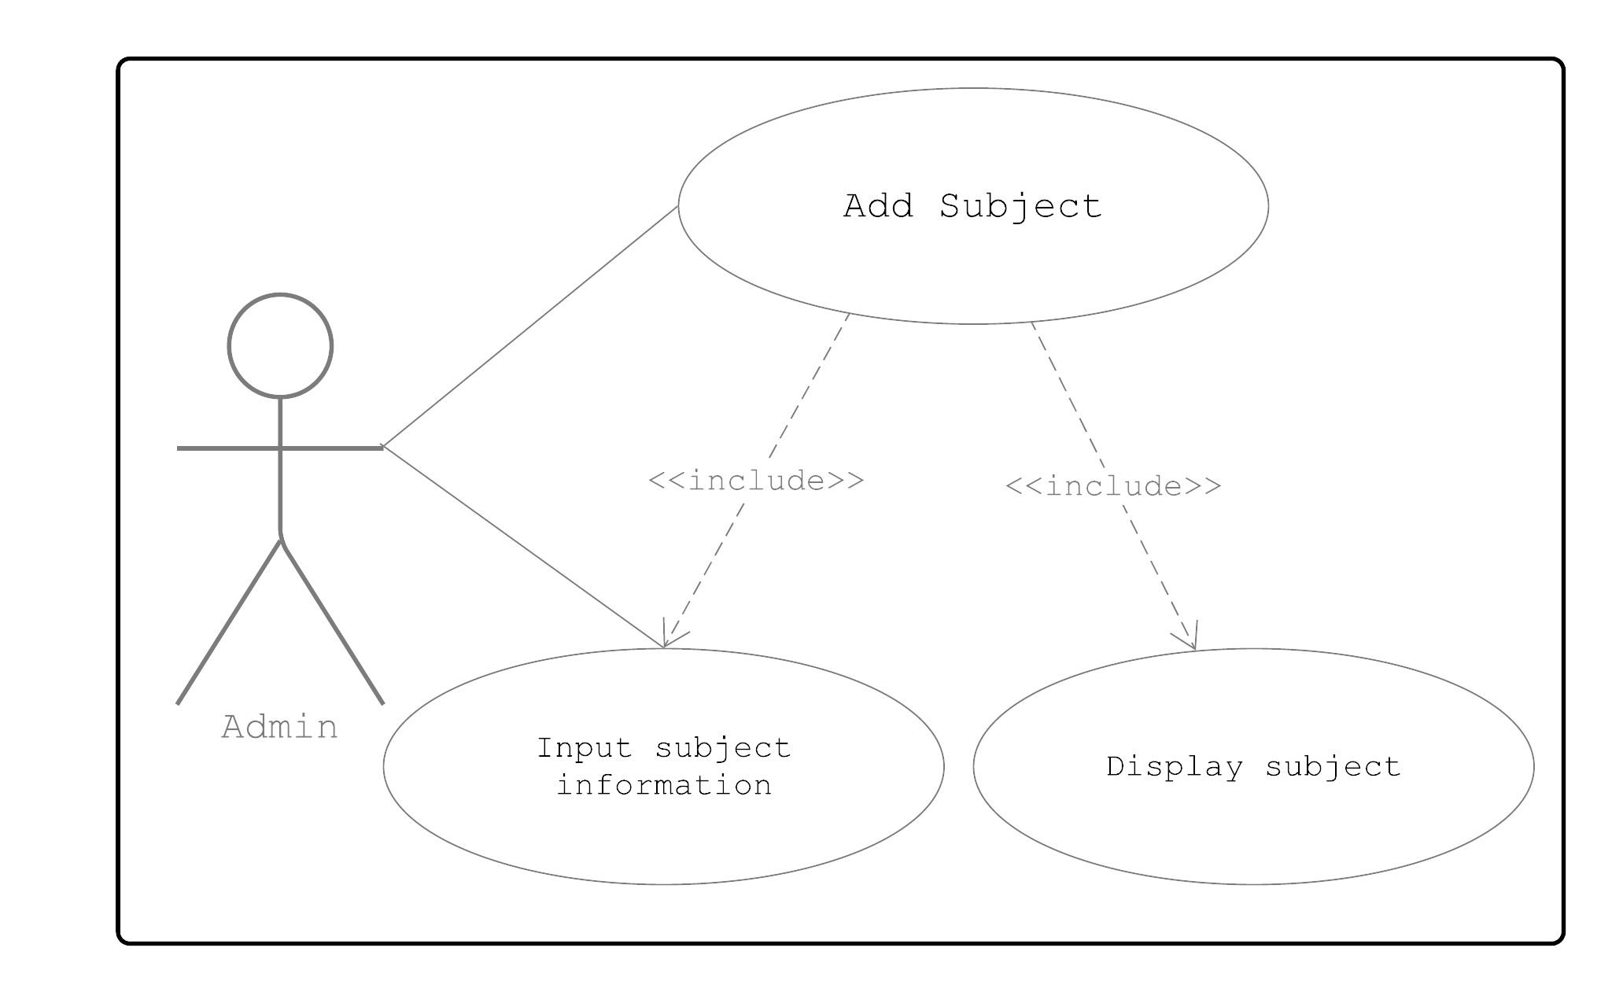

**Figure 2.8**

**Use Case Diagram for Add Subject**

|  |  |
| --- | --- |
| Use Case Name: | Add Subject |
| Actor(s): | Admin |
| Description: | The admin wants to add subjects for every year level. |
| Triggering Event: | To assign subjects to students. |
| Trigger Type: | External  Temporal |
| **Steps Performed (Main Path)** | **Information Type:** |
| 1. Input subject information | Subject form |
| 1. Click save button. | Subject form |
| Pre-condition: | Admin must have list of subjects to every year level. |
| Post-condition: | The system displays confirmation of the added subject. |
| Assumptions: | Admin must have access to the system. |

**Table 28**

**Use Case Scenario for Add Subject**

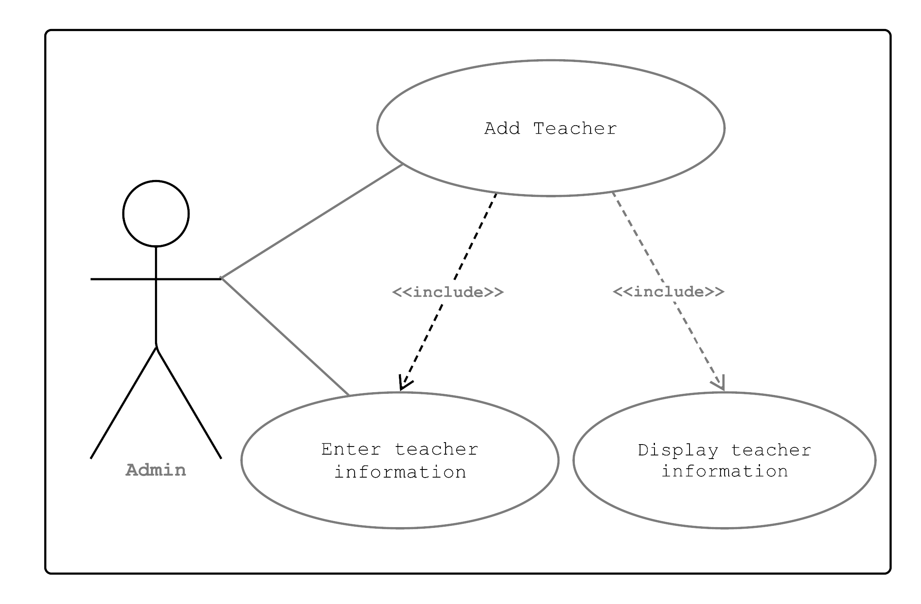

**Figure 2.9**

**Use Case Diagram for Add Teacher**

|  |  |
| --- | --- |
| Use Case Name: | Add teacher information |
| Actor(s): | Admin |
| Description: | The admin wants to add teacher information. |
| Triggering Event: | To assign teacher for new section. |
| Trigger Type: | Temporal  External |
| **Steps Performed (Main Path)** | **Information Type:** |
| 1. Display faculty form | Faculty form |
| 1. Enter teacher information | Faculty form |
| 1. Click save button | Faculty form |
| Pre-condition: | Admin must have teacher’s basic information. |
| Post-condition: | The system displays confirmation message for newly added teacher information. |
| Assumptions: | Teacher must be a staff of the establishment. |

**Table 29**

**Use Case Scenario for Add Teacher**

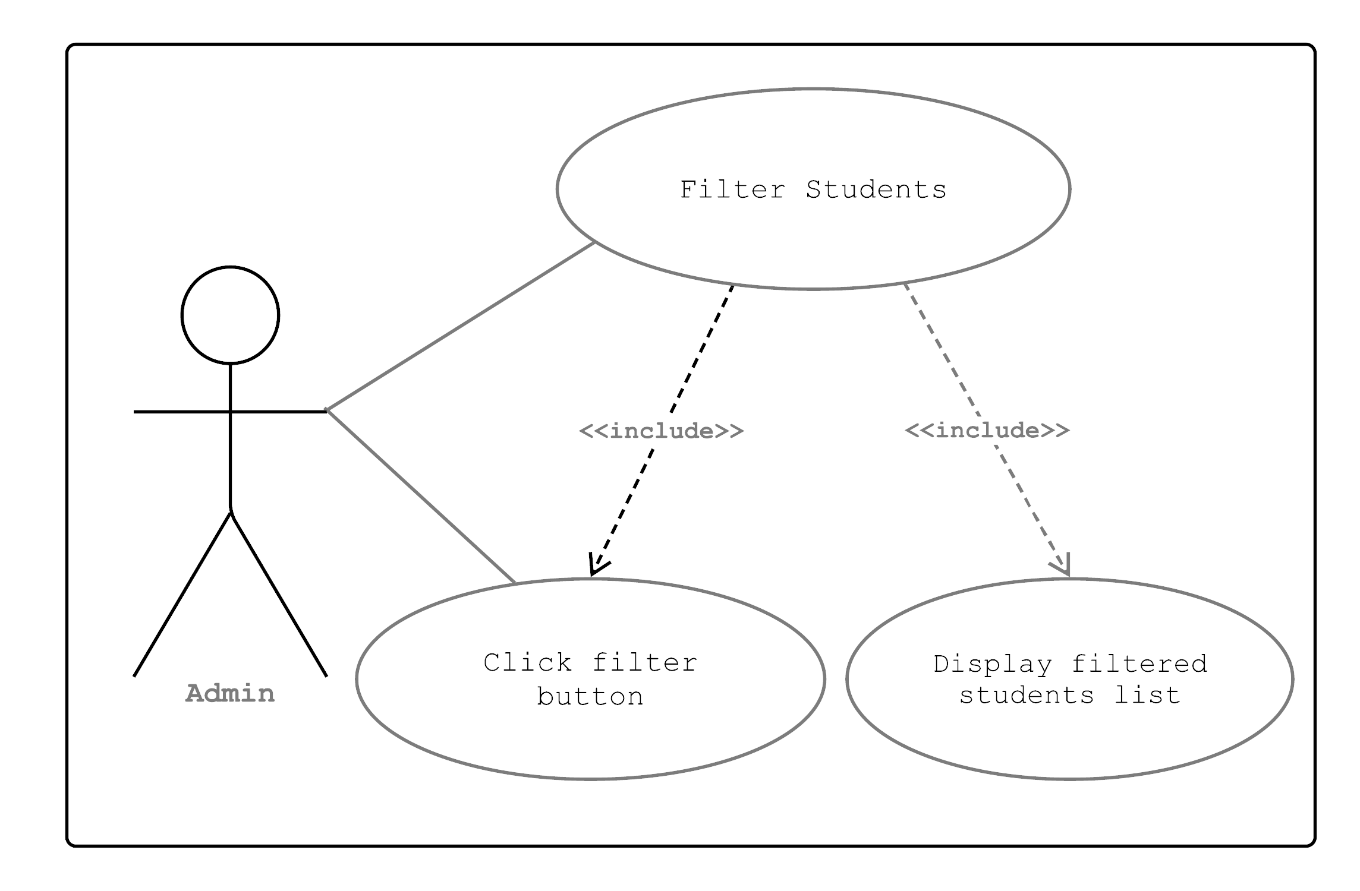

**Figure 3**

**Use Case Diagram for Filter Students**

|  |  |
| --- | --- |
| Use Case Name: | Filter student list |
| Actor(s): | Admin |
| Description: | The admin wants to filter students list by year level or by section. |
| Triggering Event: | To view students by their specific year level or section. |
| Trigger Type: | External  Temporal |
| **Steps Performed (Main Path)** | **Information Type:** |
| 1. Admin displays the list of all enrolled students. | Student list |
| 1. Admin clicks the filter button and options for filtering displays. | Filter option |
| 1. Admin chooses the option needed and system displays filtered list of students. | Student list |
| Pre-condition: | Admin must display list of all enrolled students. |
| Post-condition: | The system displays specific list of students. |
| Assumptions: | Admin must have list of students enrolled. |

**Table 30**

**Use Case Scenario for Filter Students**

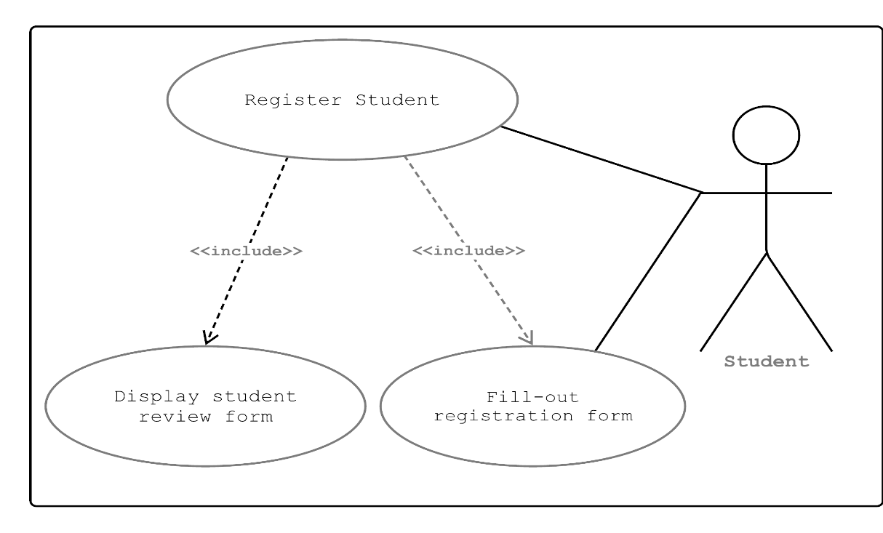

**Figure 3.1**

**Use Case Diagram for Register Student**

|  |  |
| --- | --- |
| Use Case Name: | Register student |
| Actor(s): | Student |
| Description: | The student wants to fill out registration form |
| Triggering Event: | To enroll in the said establishment. |
| Trigger Type: | Temporal  External |
| **Steps Performed (Main Path)** | **Information Type:** |
| 1. Student access the sytem. | Homepage |
| 1. Fill out the registration form displayed in the system. | Admission form |
| 1. Student submits the registration form and review of user’s information displays. | Student review form |
| Pre-condition: | The student must access to the system. |
| Post-condition: | The system saves its registration form. |
| Assumptions: | Student must have an account. |

**Table 31**

**Use Case Scenario for Register Student**

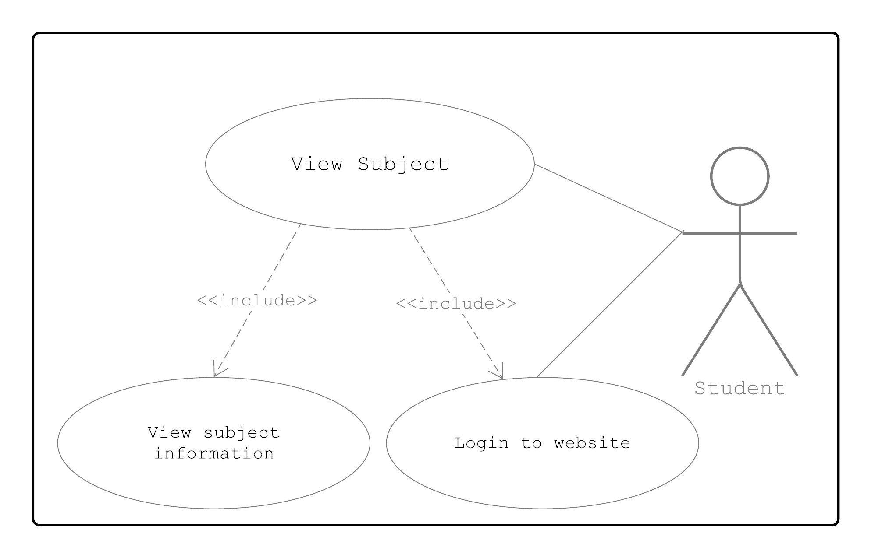

**Figure 3.2**

**Use Case Diagram for View Subject**

|  |  |
| --- | --- |
| Use Case Name: | View Subject |
| Actor(s): | Student |
| Description: | The student wants to view subject. |
| Triggering Event: | To view subjects by their specific grade level. |
| Trigger Type: | Temporal  External |
| **Steps Performed (Main Path)** | **Information Type:** |
| 1. Student logs in to the website. | Login form |
| 1. Student views subjects in their profile. | Profile form |
| Pre-condition: | The student must be enrolled. |
| Post-condition: | The system displays student’s subject. |
| Assumptions: | Student must have username and password. |

**Table 32**

**Use Case Scenario for View Subject**

**Table 32**

**Use Case Scenario for View Subject**

**EVENT TABLE**

Event tableis a table of data that is typically written to the log file for each scenario and also appears in the Analysis window. The event table contains timing information about specific events that occur during the scenario.

|  |  |  |  |  |  |
| --- | --- | --- | --- | --- | --- |
| **Event** | **Trigger** | **Source** | **Use Case** | **Response** | **Destination** |
| Admin wants to login | To access the System | Admin | Admin Login | Confirmation for admin login | System |
| Admin wants to add new student information | To enroll new students | Student | Add Student | Confirmation for student information/ Display student information | Admin |
| Admin wants to update student information | To change student information | Student | Update Student | Display updated student information | Admin |
| Admin wants to search student information | To find student information | System | Search Student | Display student information | Admin |
| Admin wants to delete student information | Double entry of students information | System | Delete Student | Displays confirmation message for deleted student | Admin |
| Admin wants to display student list | To view enrolled students | System | Display Student List | Display student list | Admin |
| Admin wants to add grade level and section | To assign grade level and section to students | Admin | Add grade level and section | Display added grade level and section | Student |
| Admin wants to add subject | To assign subjects per grade level | Admin | Add Subject | Display subjects | System |
| Admin wants to add teacher information | To assign teacher for new section | Teacher | Add Teacher | Confirmation for added teacher information | Admin |
| Admin wants to filter students | To view students by their specific year level or section. | System | Filter Student | Display filtered list of students | Admin |
| Student wants to fill out registration form | To enroll for the said establishment | Student | Register Student | Confirmation for student information/ Display student information | Admin |
| Student wants to view subject | To view subjects by their specific grade level | System | View Subject | Display subject information | Student |

**Table 33**

**Event Table**

**ACTIVITY DIAGRAM**

Activity diagrams are graphical representations of workflows of stepwise activities and actions with support for choice, iteration and concurrency.

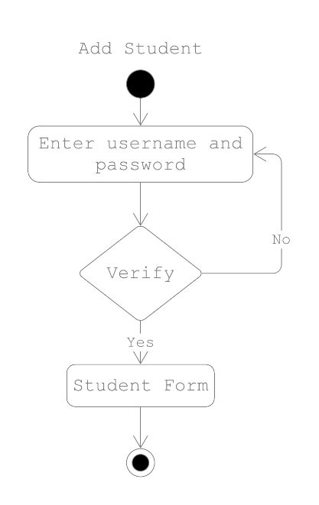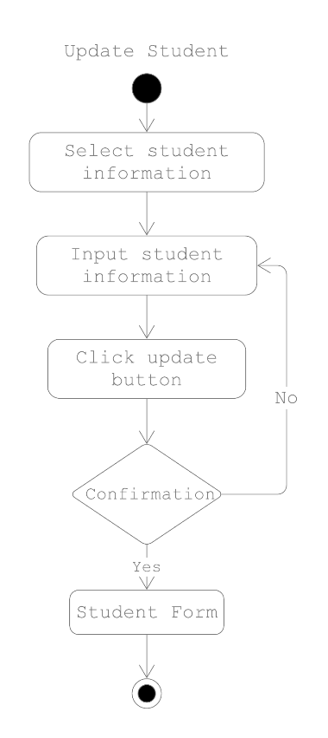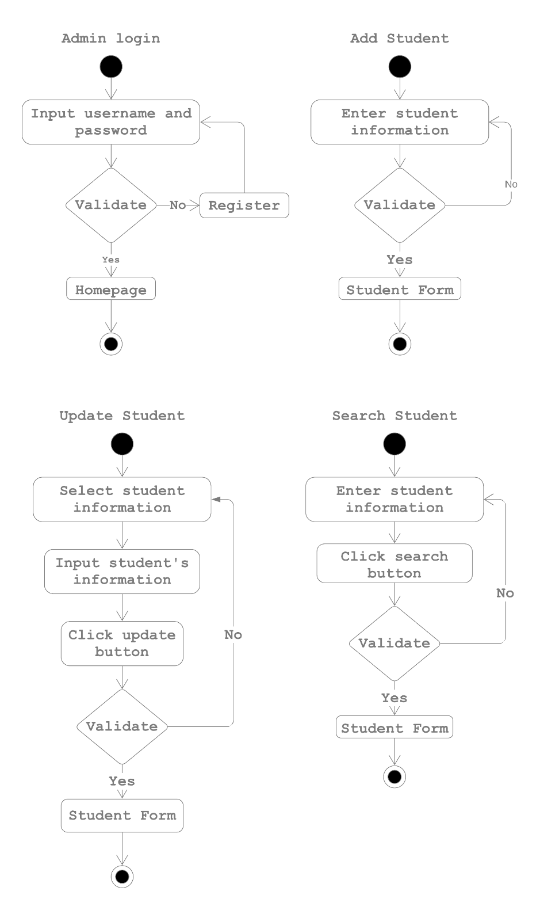

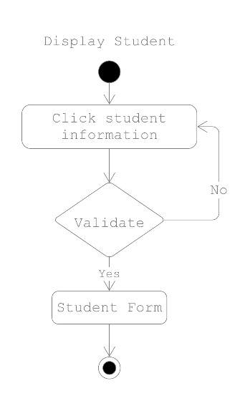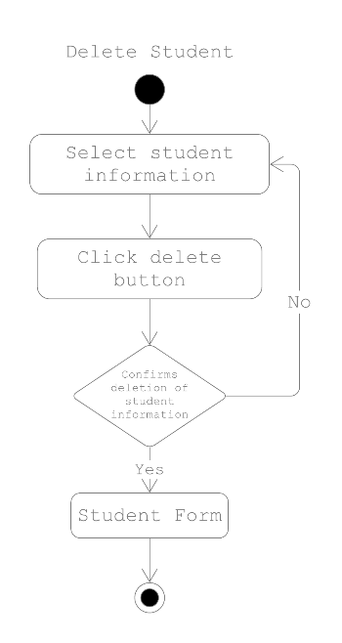 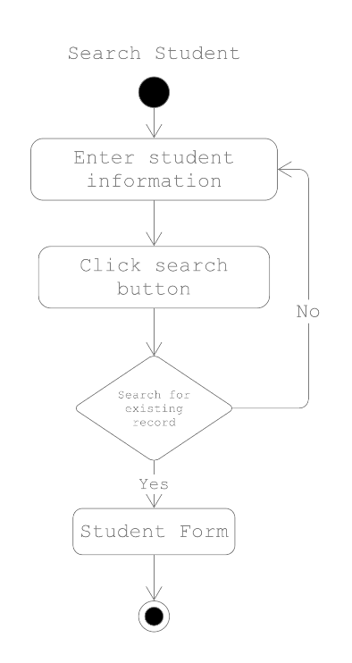

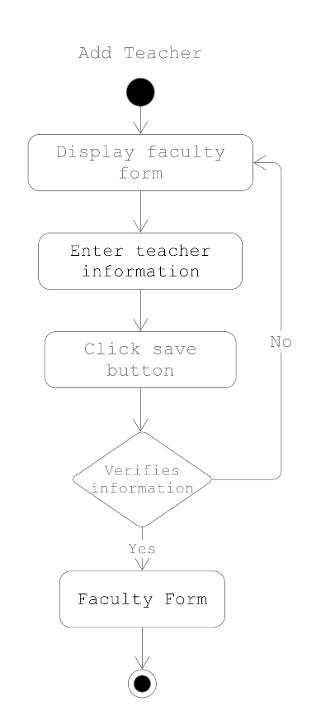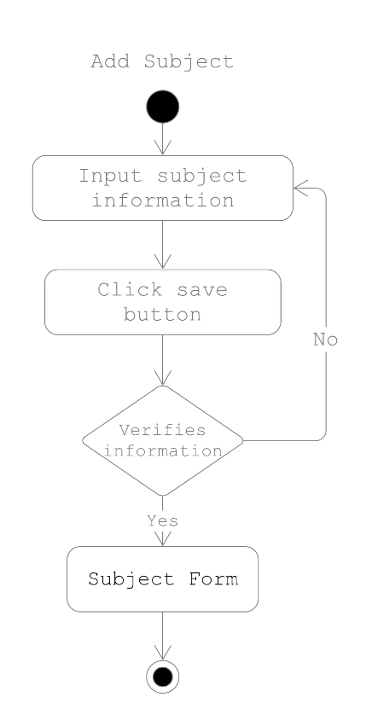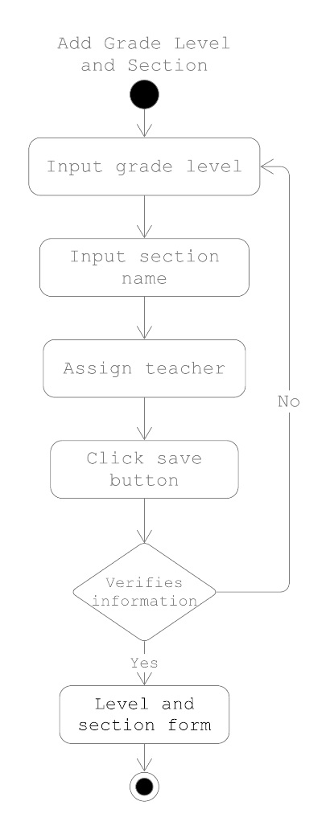

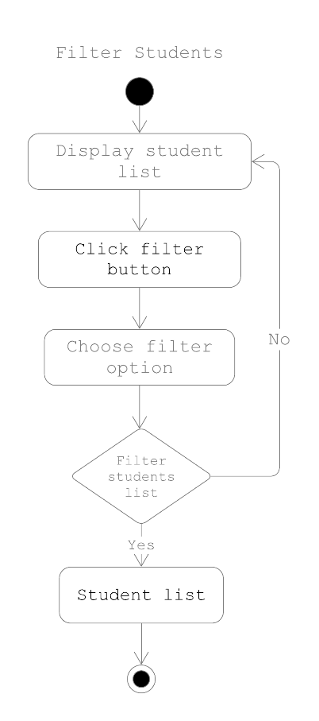

**Figure 4**

**Activity Diagrams of Medellin National High School Online Enrollment System**

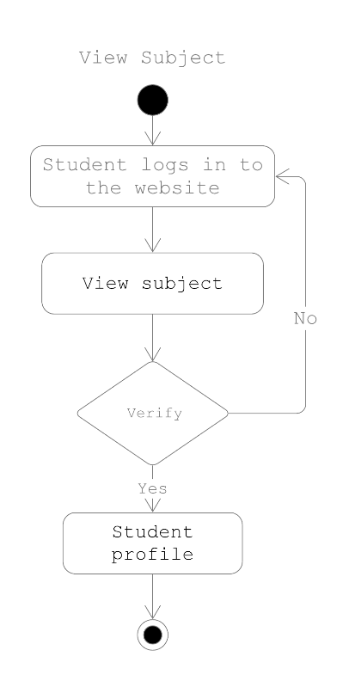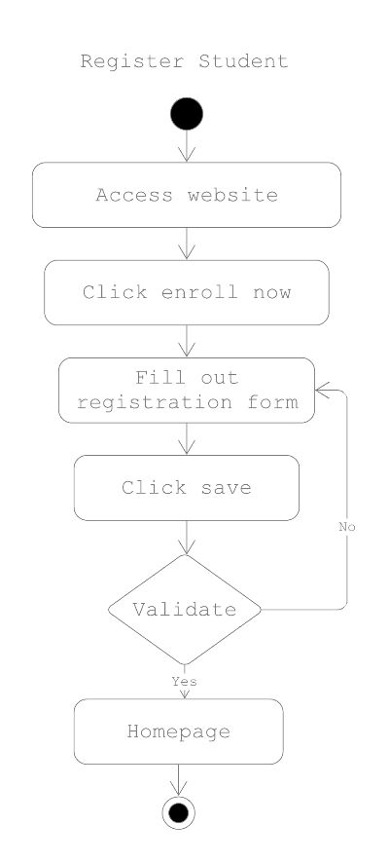

**ENTITY-RELATIONSHIP DIAGRAM**

Entity Relationship Diagram (ERD)it is a data modelling technique that creates a graphical representation of the relationship of entities within the system. Entity refers to data that has been collected such a person, object, place or event.

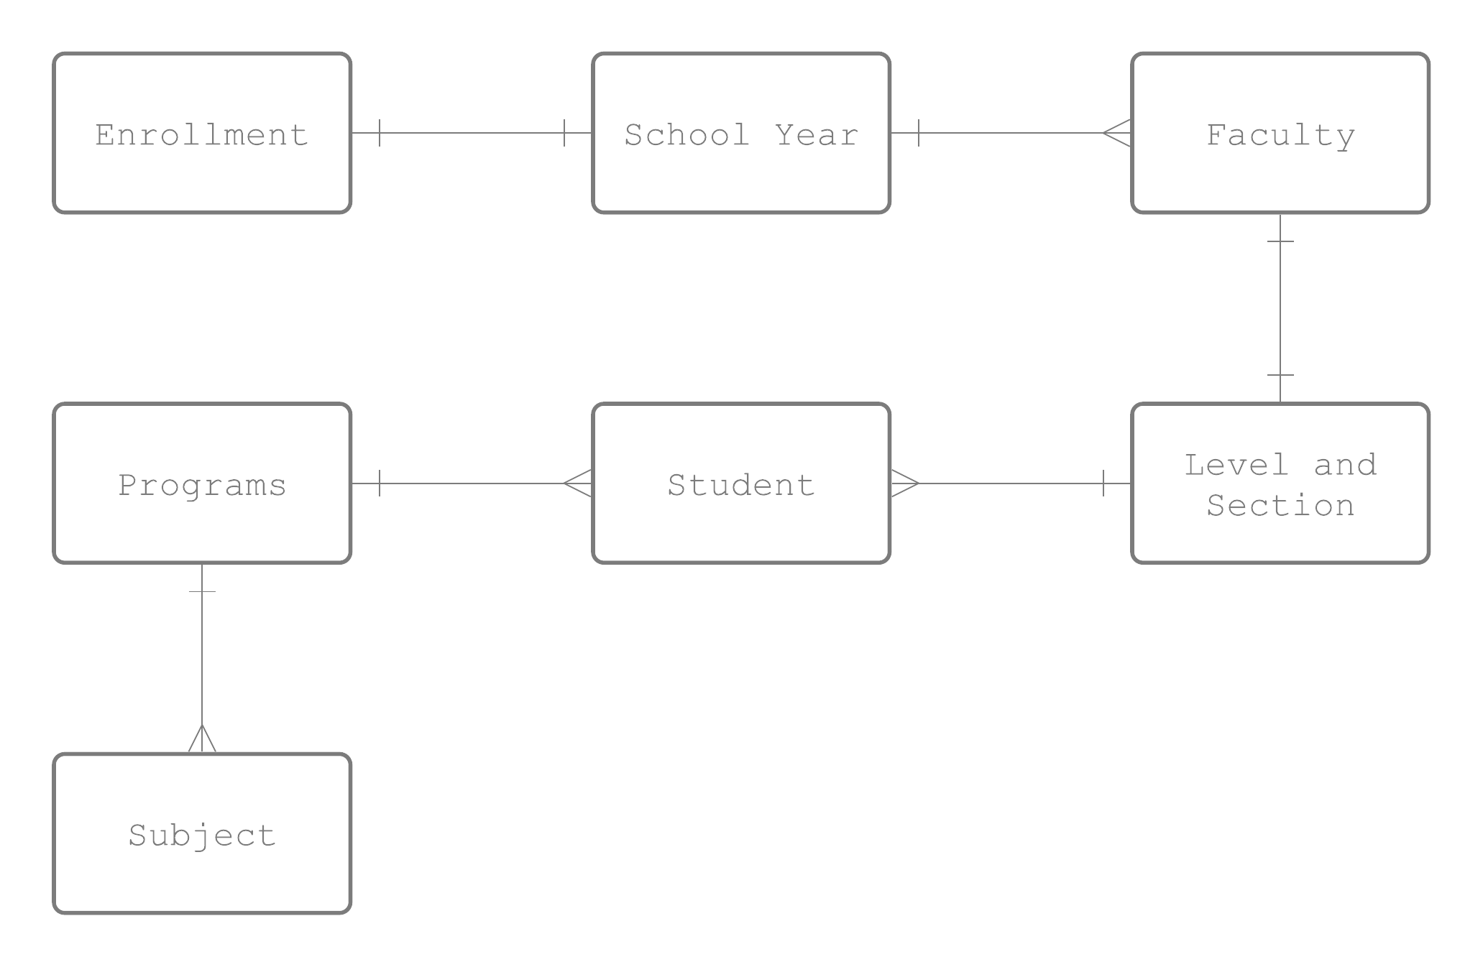

**Figure 5**

**Entity-Relationship Diagram of Medellin National High School Online Enrollment**

**Figure 5**

**Entity-Relationship Diagram of Medellin National High School Online Enrollment**

**CLASS DIAGRAM**

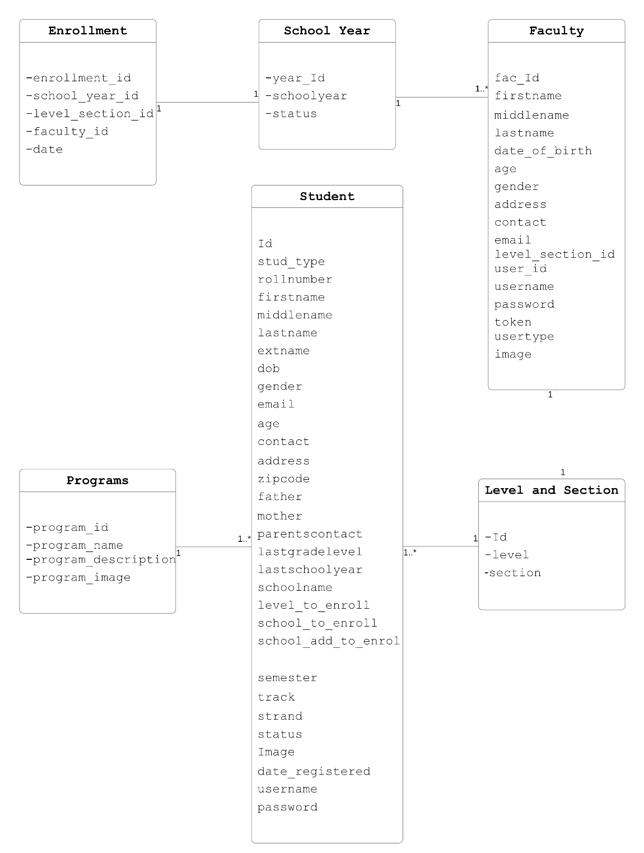Classdiagram describes the structure of a system by showing the system's classes, their attributes, operations (or methods), and the relationships among objects.

**Figure 6**

**Class Diagram of Medellin National High School Online Enrollment**

**METADATA**

Metadata is structured reference data that helps to sort and identify attributes of the information it describes.

|  |  |  |
| --- | --- | --- |
| Field Name | Data Type and Values | Description |
| enrollment_id | int(11) | Identifies the enrollment ID |
| school_year_id | int(30) | Identifies the school year ID |
| level_section_id | int(30) | Identifies the level and section ID |
| faculty_id | int(30) | Identifies the faculty ID |
| date | date | Identifies the date of enrollment |

Table 34: Enrollment

Table 35: School Year

|  |  |  |
| --- | --- | --- |
| Field Name | Data Type and Values | Description |
| year_Id | int(11) | Identifies the school year ID |
| schoolyear | Varchar(255) | Identifies the school year |
| status | Varchar(255) | Identifies the status of school year |

Table 36: Faculty

|  |  |  |
| --- | --- | --- |
| Field Name | Data Type and Values | Description |
| fac_Id | int(11) | Identifies the faculty ID |
| firstname | varchar(255) | Identifies the first name of teacher |
| middlename | varchar(255) | Identifies the middle name of teacher |
| lastname | varchar(255) | Identifies the last name of teacher |
| date_of_birth | varchar(255) | Identifies the birthday of teacher |
| age | varchar(255) | Identifies the age of teacher |
| gender | varchar(255) | Identifies the gender of teacher |
| address | varchar(255) | Identifies the address of teacher |
| contact | varchar(255) | Identifies the contact of teacher |
| email | varchar(255) | Identifies the email of teacher |
| level_section_id | int(30) | Identifies the ID of level and section that the teacher is assigned |
| user_id | int(30) | Identifies the ID of individual user/teacher |
| username | varchar(255) | Identifies the username of teacher |
| password | varchar(255) | Identifies the password of teacher |
| token | varchar(255) | Identifies the token of teacher |
| usertype | varchar(255) | Identifies the user type of teacher |
| image | varchar(255) | Identifies the image of teacher |

Table 37: Level and Section

|  |  |  |
| --- | --- | --- |
| Field Name | Data Type and Values | Description |
| Id | int(11) | Identifies the ID of level and section |
| level | varchar(255) | Identifies the grade level |
| section | varchar(255) | Identifies the section |

|  |  |  |
| --- | --- | --- |
| Field Name  Table 38: Student | Data Type and Values | Description |
| Id | int(11) | Identifies the ID of level and section |
| stud_type | varchar(255) | Identifies the grade level |
| rollnumber | varchar(255) | Identifies the section |
| firstname | varchar(255) | Identifies the first name of student |
| middlename | varchar(255) | Identifies the middle name of student |
| lastname | varchar(255) | Identifies the last name of student |
| extname | varchar(255) | Identifies the extension name of student |
| dob | varchar(255) |  |
| gender | varchar(255) | Identifies the gender of student |
| email | varchar(255) | Identifies the email of student |
| age | varchar(255) | Identifies the age of student |
| contact | varchar(255) | Identifies the contact number of student |
| address | varchar(255) | Identifies the barangay of student |
| zipcode | varchar(255) | Identifies the zip code of student |
| father | varchar(255) | Identifies the father’s name of student |
| mother | varchar(255) | Identifies the mother’s name of student |
| parentscontact | varchar(255) | Identifies the contact number the student’s parents |
| lastgradelevel | varchar(255) | Identifies the last grade level attended |
| lastschoolyear | varchar(255) | Identifies the last school year attended |
| schoolname | varchar(255) | Identifies the name of school last attended |
| level_to_enroll | varchar(255) | Identifies the grade level to enroll |
| school_to_enroll | varchar(255) | Identifies the school to enroll |
| school_add_to_enroll | varchar(255) | Identifies the address of school to enroll |
| semester | varchar(255) | Identifies the semester to enroll |
| track | varchar(255) | Identifies what track the student wants to enroll |
| strand | varchar(255) | Identifies what strand the student wants to enroll |
| status | varchar(255) | Identifies the status of the student |
| Image | varchar(255) | Identifies the image attached by student |
| date_registered | varchar(255) | Identifies the date student registered |
| username | varchar(255) | Identifies the student’s username |
| password | varchar(255) | Identifies the student’s password |

Table 39: Programs

|  |  |  |
| --- | --- | --- |
| Field Name | Data Type and Values | Description |
| program_id | int(11) | Identifies the ID of programs |
| program_name | varchar(255) | Identifies the program |
| program_description | varchar(255) | Identifies the description of the program |
| program_image | varchar(255) | Identifies the image of the program |

Table 40: Subject

|  |  |  |
| --- | --- | --- |
| Field Name | Data Type and Values | Description |
| Id | int(11) | Identifies the subject Id |
| Level | varchar(255) | Identifies the grade level to assign subjects |
| Subject | varchar(255) | Identifies the subject in every grade level |

**DESIGN OF THE PROTOTYPE**

**Homepage**

2

3

4

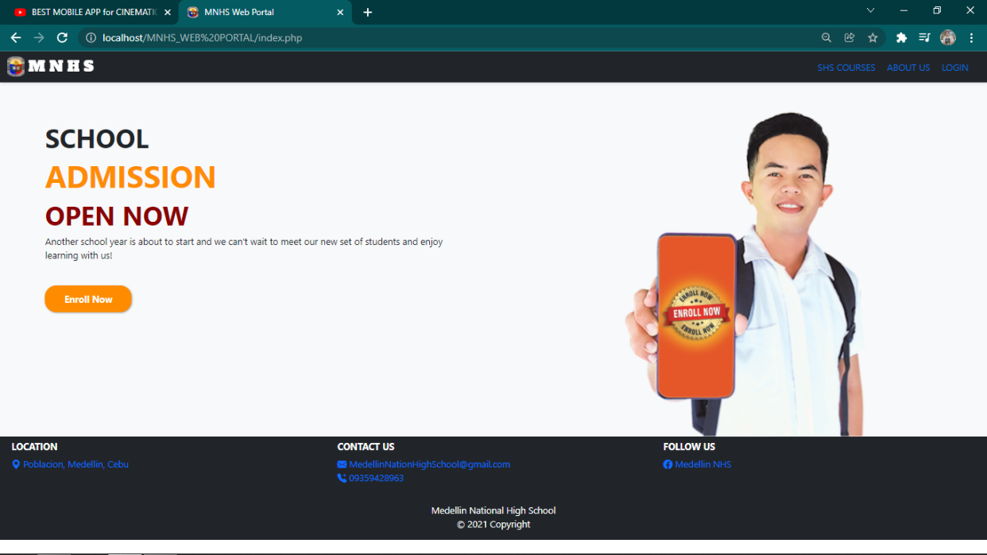

1

1. **Enroll now –** button for accessing student’s admission form.

2. **SHS Courses –** tab to view offered programs for senior high school.

3. **About us –** tab to view information about school.

4. **Login –** button used for accessing the log in form for admin and students.

**Admission Form**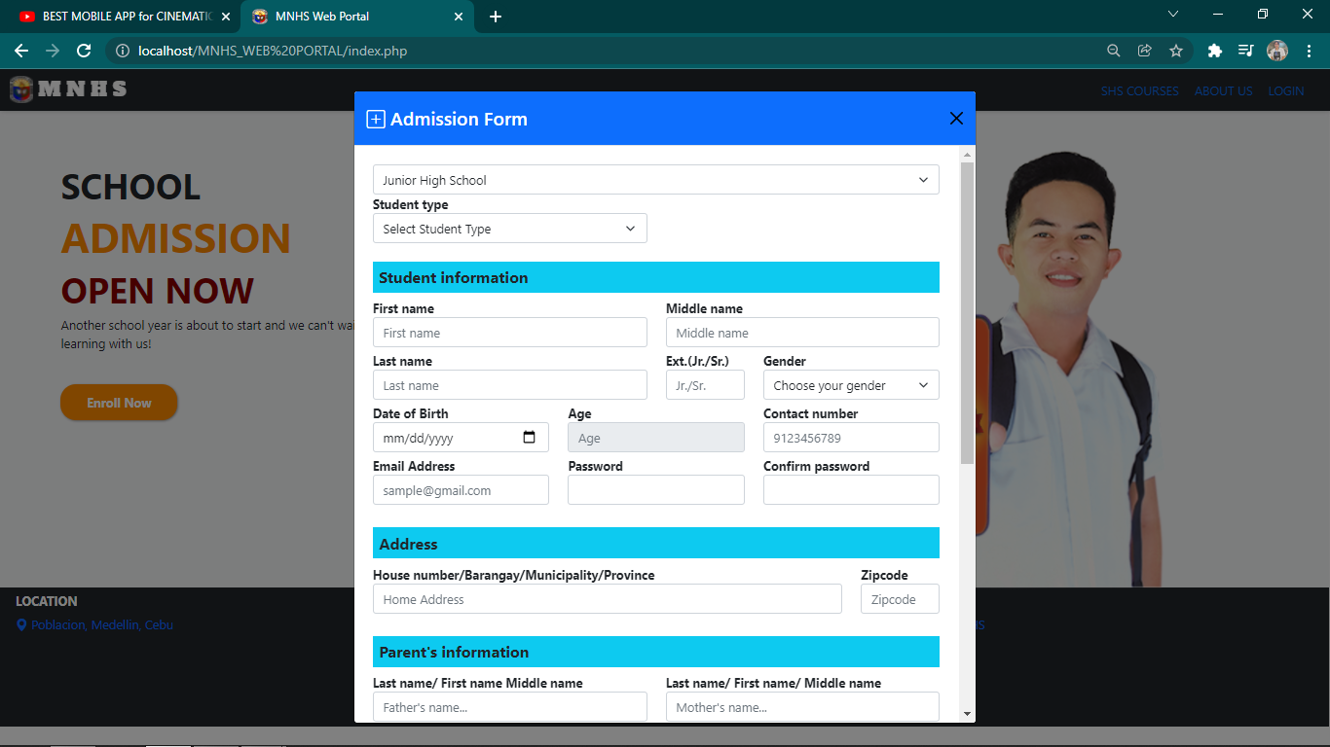

1

2

3

6

4

7

5

10

9

11

8

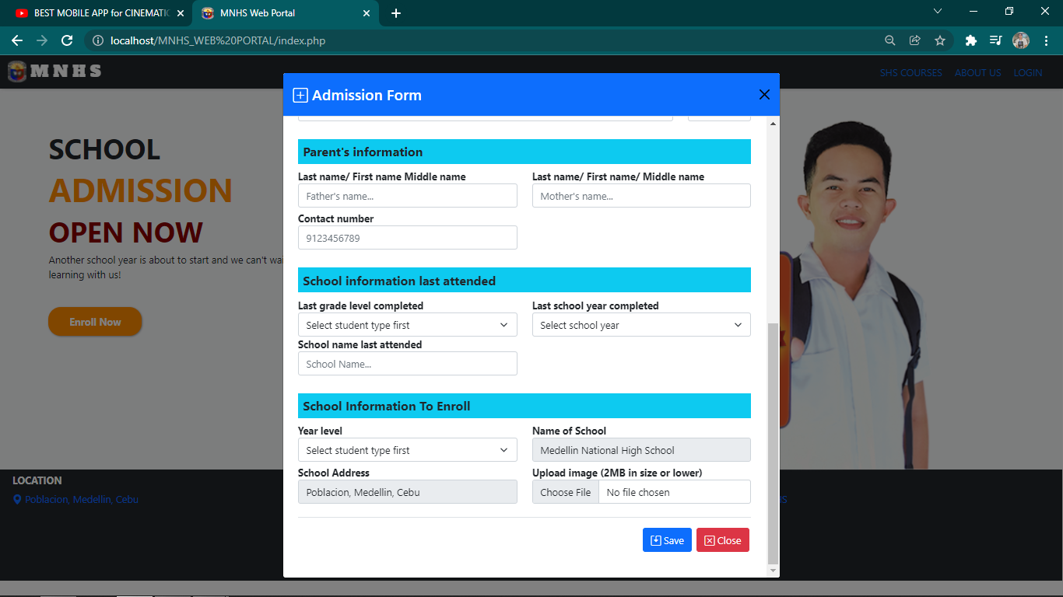1. **Exit button –** button used to exit admission for.

25

23

22

20

19

17

15

12

28

27

26

24

21

18

16

14

13

2. **JH/SHS Dropdown –** dropdown used to choose which category to enroll.

3. **Student type –** dropdown used for selecting student type.

4. **First name –** textbox used to input student’s first name.

5. **Middle name –** textbox used to input student’s middle name.

6. **Last name –** textbox used to input student’s last name.

7. **Extension –** optional textbox for students with extension in their names.

8. **Gender –** dropdown for student’s gender.

9. **Date of Birth –** textbox for student’s date of birth.

10. **Age –** textbox that shows the computed age from student’s date of birth.

11. **Contact number –** textbox for student’s contact number.

12. **Email Address –** textbox used to input email address of student.

13. **Password -** textbox used to set the password of student.

14. **Confirm password –** textbox used to input the set password for its confirmation.

15. **Home Address –** textbox used to input the complete address of the student.

16. **Zip code –** textbox used to input the zip code of student’s municipality or city.

17. **Father’s name –** textbox used to input father’s name of the student.

18. **Mother’s name –** textbox used to input mother’s name of the student.

19. **Contact number –** textbox used to input father/mother’s contact number.

20. **Student type –** dropdown used to choose the last grade level the student attended.

21. **Last school year –** dropdown used to choose the last school year attended.

22. **Last school name –** textbox used to input the last school attended.

23. **School type –** dropdown used to choose the grade level to enroll to.

24. **School name –** textbox already set to MNHS in which the student wants to enroll.

25. **School address –** address of the school that is automatically set.

26. **Upload file –** used in setting the profile picture for the student.

27. **Save button –** button used to save and submit the admission form filled-in by the student.

28. **Close button –** button used to close the admission form.

**Login Form**

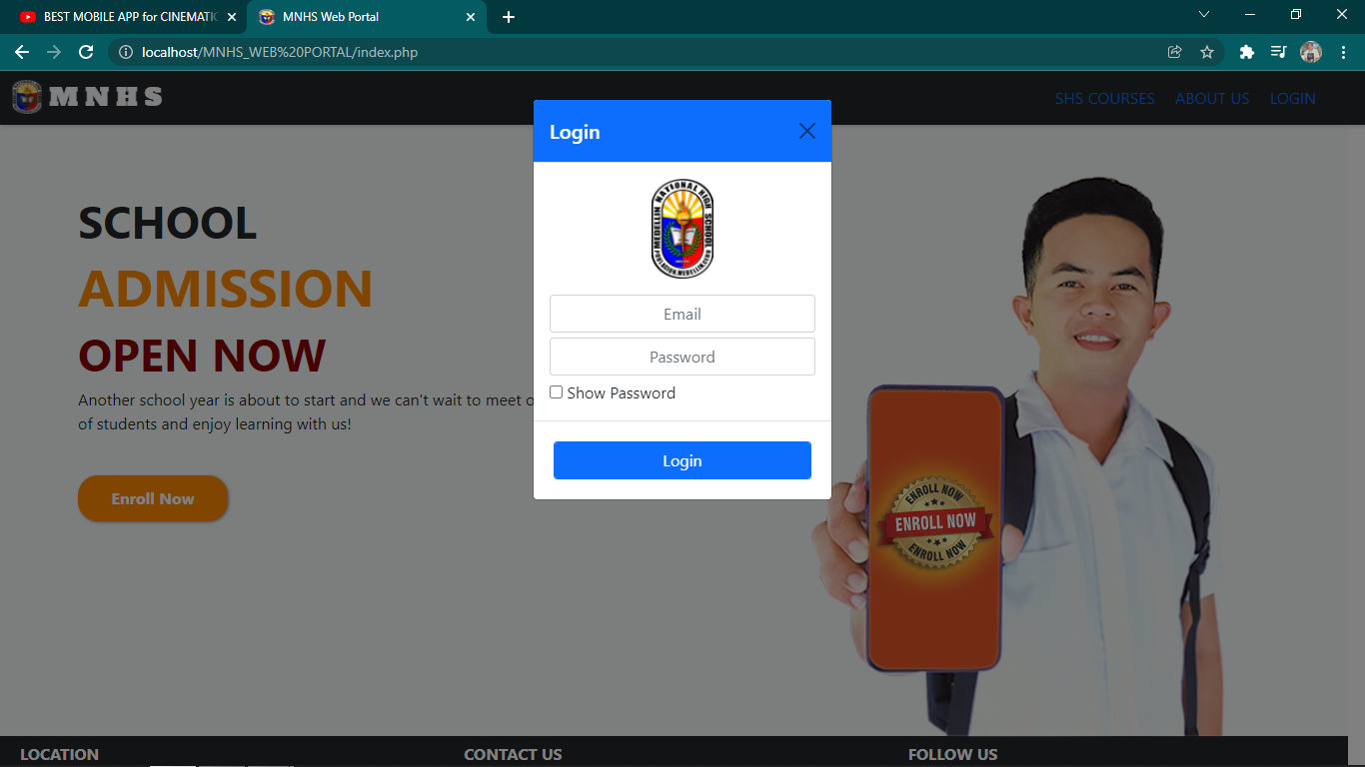

4

2

1

3

1. **Show Password –** checkbox used to show or hide password.

2. **Email –** textbox to input email of student or admin.

3. **Password –** textbox used to input the password.

4. **Login –** button used in verifying username and password, if match, student will be directed to student’s account and admin will be directed to admin dashboard.

**Admin Page**

13

12

11

10

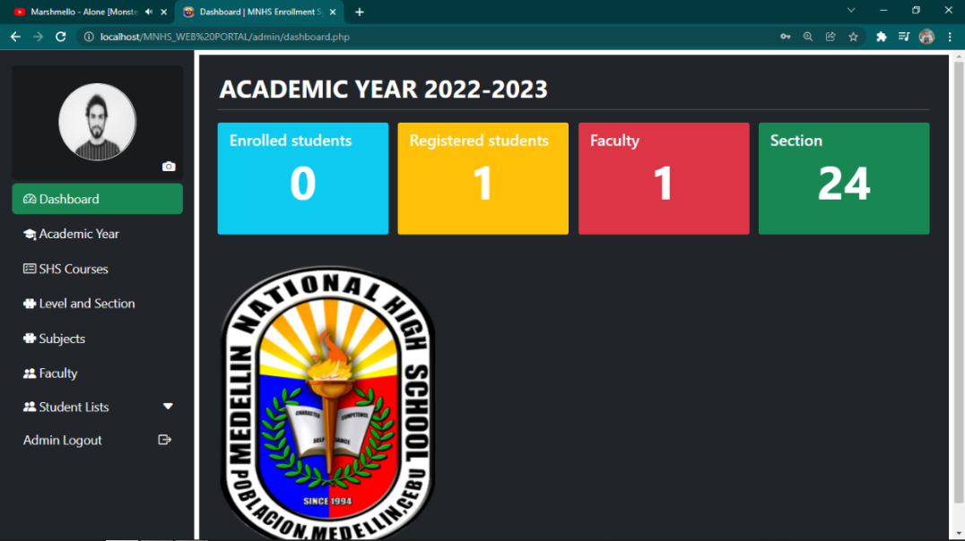

3

2

1

4

5

7

64

9

8

1. **Profile –** icon used to access the profile of the admin.

2. **Dashboard -** button used to access the dashboard of admin.

3. **Academic Year –** button used to access the page for academic year.

4. **SHS Courses –** button used to access the SHS courses page and manage SHS programs.

5. **Level and Section –** button used to access the level and section page.

6. **Subjects –** button used to access the page for managing subjects.

7. **Faculty –** button for accessing faculty page.

8. **Student list –** button for accessing the page for registered and enrolled students and also the previous enrollment.

9. **Admin logout –** button used to log out admin account.

10. **Enrolled Students –** dashboard used to display total number of enrolled students.

11. **Registered Students –** dashboard used to display total number of registered students.

12. **Faculty –** dashboard used to display the total number of faculty.

13. **Section –** dashboard used to display the total number of sections**.**

**Admin Profile Page**

1

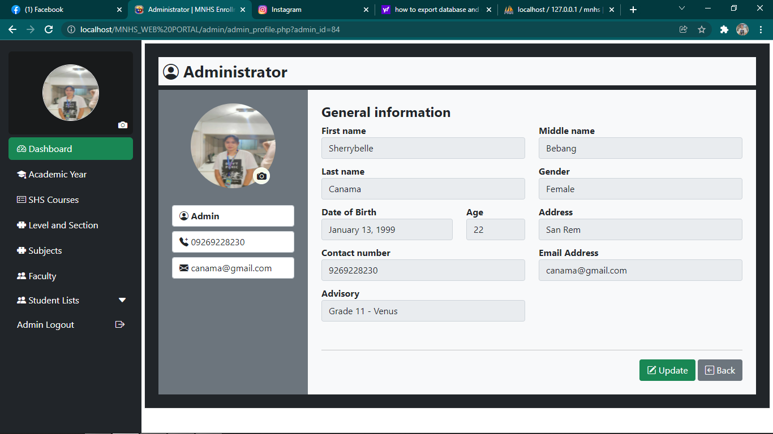

3

2

1. **Edit icon –** button used to access the page for editing admin’s profile.

2. **Update –** button used to update admin’s information.

3. **Back –** button used to return to the admin dashboard.

**School Year Management Page**

2

1

3

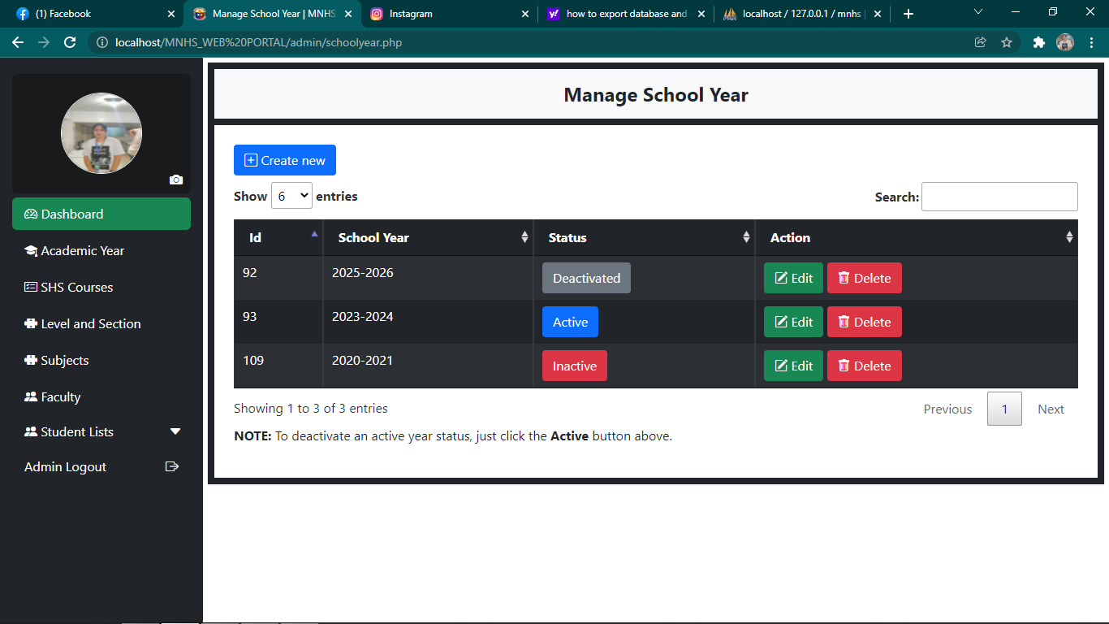

7

6

5

43

1. **Create New –** button used to create new school year.

2**. Filter –** button used to filter the number of school year to display.

3. **Search bar** **–** used to search school year.

4. **Edit Button –** button used to set school year either active, inactive or to deactivate school year.

5. **Delete Button -** button used to delete school year.

6. **Previous Button –** button used to go back to previous page of the school year.

7. **Next Button –** button used to go to the next page of the school year.

**Creating New School Year**

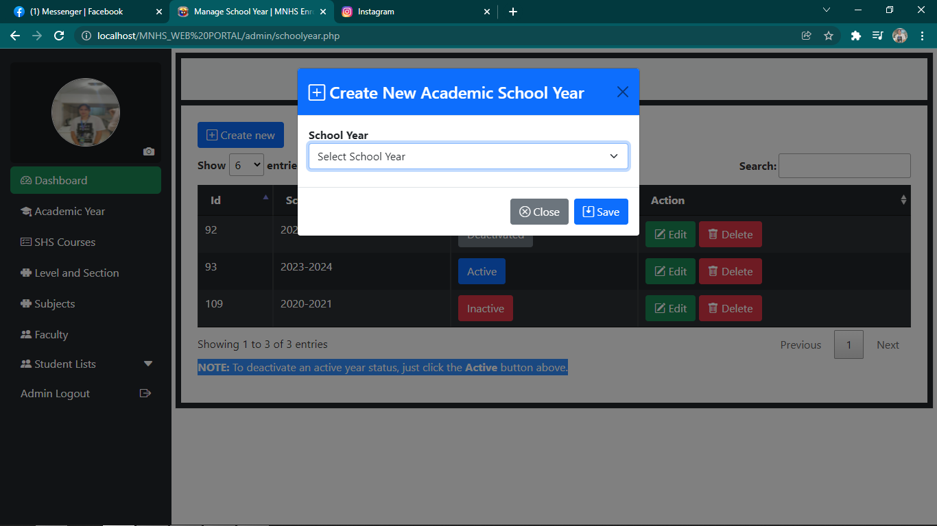

1

4

3

2

1. **Exit Button –** button used to exit form in creating new academic school year.

2. **School Year Dropdown –** used to select new academic school year.

3. **Close Button –** button used to close form in creating new academic school year.

4. **Save Button –** button used to save the newly created academic school year.

**Updating School Year**

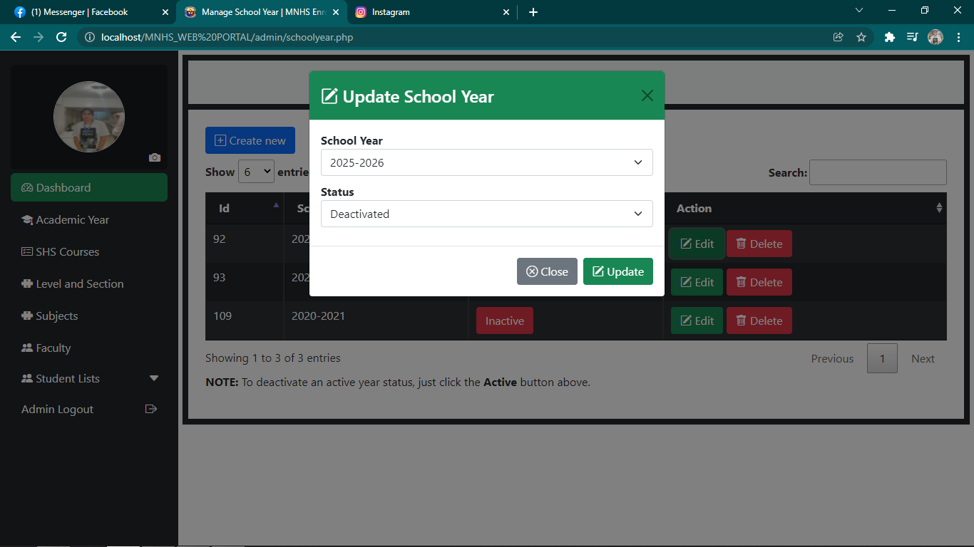

1

5

4

3

2

1. **Exit Button –** button used to exit form in updating school year.

2. **School Year Dropdown –** used to select the school year to be updated.

3. **Status –** dropdown used to select the status of the school year to be updated.

4. **Close Button –** button used to close form in updating school year.

5. **Update Button –** button used to save the updated academic school year.

**SHS Courses Management Page**

2

3

1

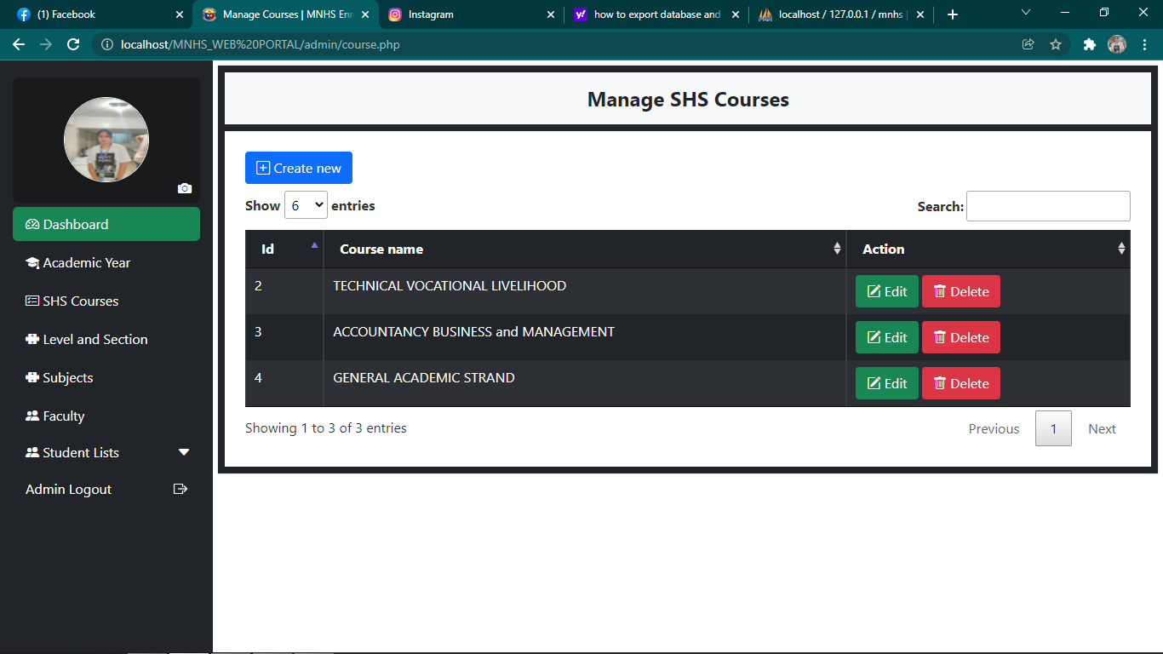

7

6

5

4

1. **Create New –** button used to create new SHS strand.

2**. Filter –** button used to filter the number of SHS strand to display.

3. **Search Bar** **–** used to search SHS strand.

4. **Edit Button –** button used edit SHS strand’s information.

5. **Delete Button -** button used to delete SHS strand.

6. **Previous Button –** button used to go back to previous page of the SHS strand.

7. **Next Button –** button used to go to the next page of the SHS strand.

**Updating SHS Courses**

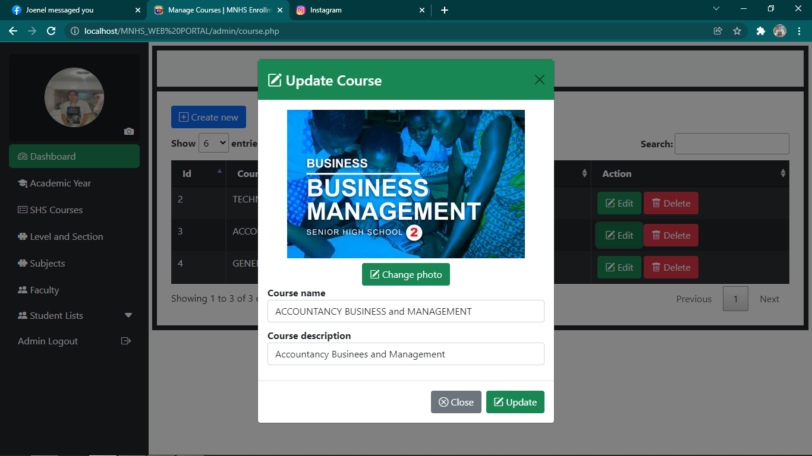

1

2

3

4

5

6

1. **Exit Button –** button used to exit the form in updating SHS courses.

2. **Change Photo –** button used to change the photo of the SHS course.

3. **Course Name –** textbox used to input the SHS course.

4. **Course Description –** textbox used to input SHS course description.

4. **Close Button –** button used to close form in updating SHS course.

5. **Update Button –** button used to save the updated SHS course.

**Updating Course Photo**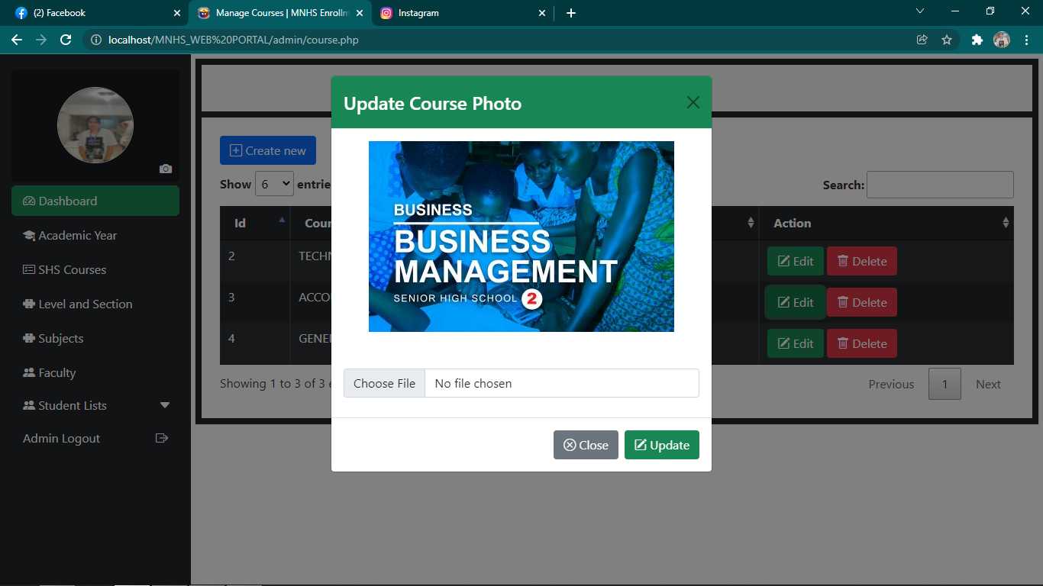

1

2

4

3

1. **Exit Button –** button used to exit the form in updating course photo.

2. **Choose File –** button used to choose photo for the SHS course.

3. **Close Button –** button used to close form in updating course photo.

4. **Update Button –** button used to save the updated course photo.

**Level and Section Management Page**

3

2

1

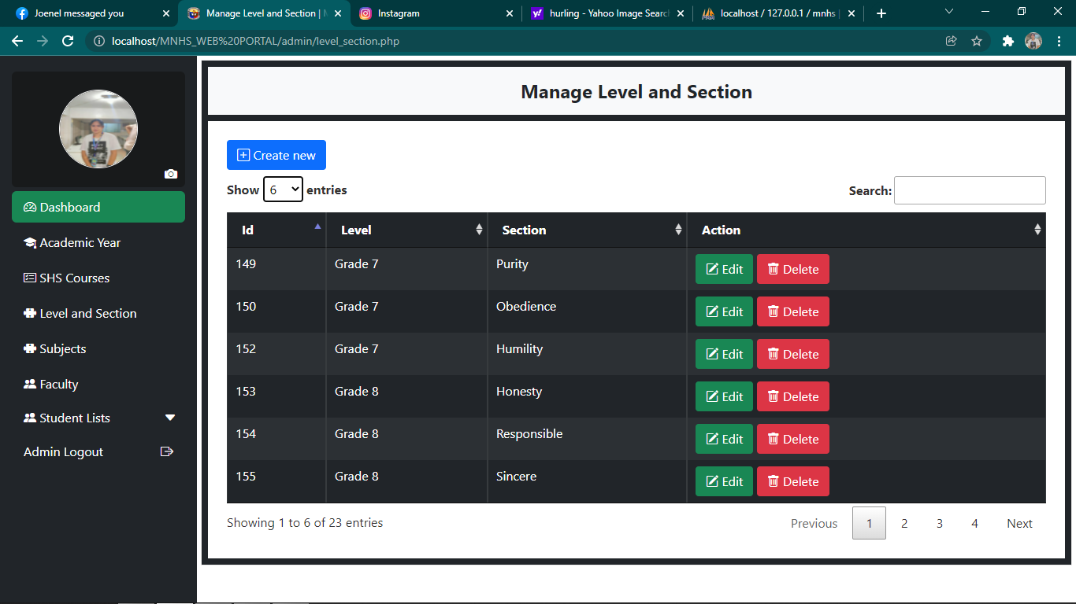

5

4

7

6

1. **Create New –** button used to create new grade level and section.

2**. Filter –** button used to filter the number of level and section to display.

3. **Search Bar** **–** used to search grade level and section.

4. **Edit Button –** button used edit grade level and section’s information.

5. **Delete Button -** button used to delete grade level and section.

6. **Previous Button –** button used to go back to previous page of the level and section.

7. **Next Button –** button used to go to the next page of the level and section.

**Creating New Level and 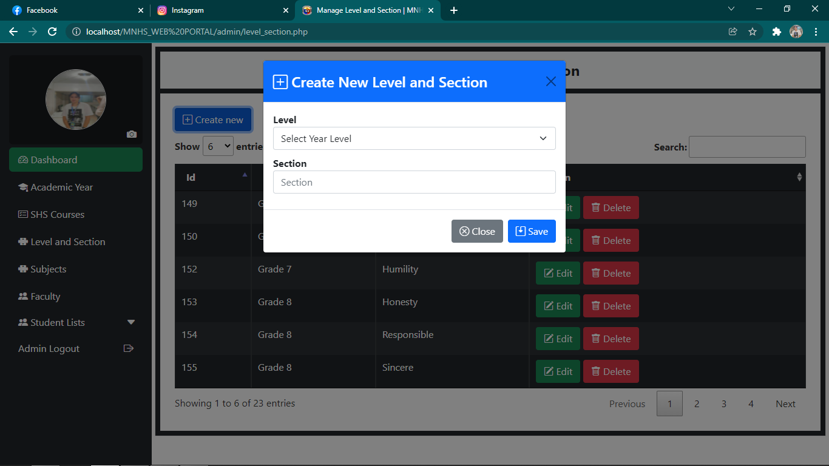Section**

1

2

5

4

3

1. **Exit Button –** button used to exit the form in creating new level and section.

2. **Level –** dropdown used to choose grade level.

3. **Section –** textbox used to input new section to be created.

4. **Close Button –** button used to close form in creating new grade level and section.

4. **Save Button –** button used to save the newly created grade level and section.

**Updating Level and Section**

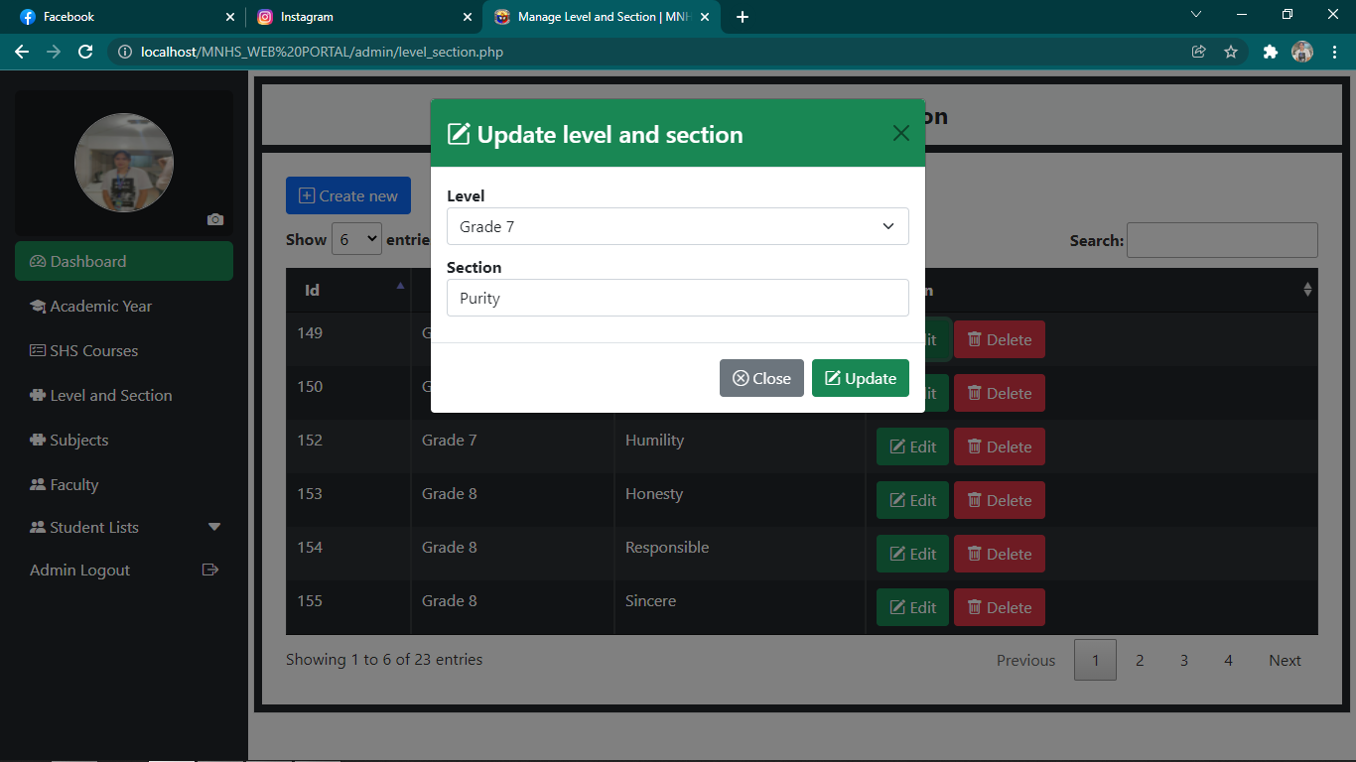

1

2

3

5

4

1. **Exit Button –** used to exit the form in updating level and section.

2. **Level –** dropdown button used to select grade level.

3. **Section –** textbox used to input section.

4. **Close Button –** button used to close the form of updating level and section.

5. **Update button –** button used to save the updated level and section.

**Subject Management**

3

2

1

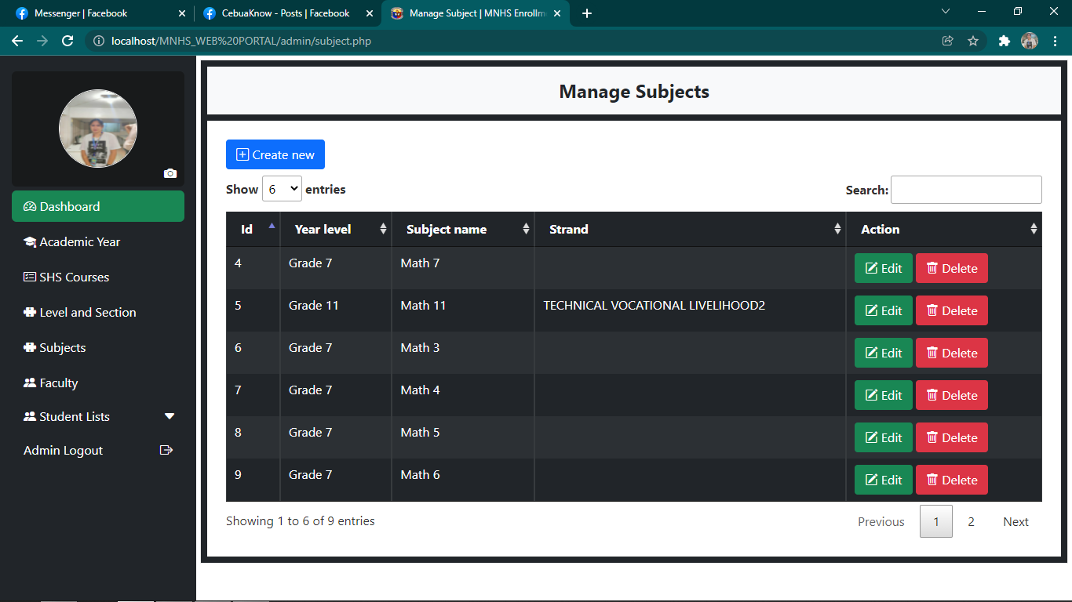

4

6

7

5

1. **Create New –** button used to create new grade level and section.

2**. Filter –** button used to filter the number of level and section to display.

3. **Search Bar** **–** used to search grade level and section.

4. **Edit Button –** button used edit grade level and section’s information.

5. **Delete Button -** button used to delete grade level and section.

6. **Previous Button –** button used to go back to previous page of the level and section.

7. **Next Button –** button used to go to the next page of the level and section.

**Creating New Subject**

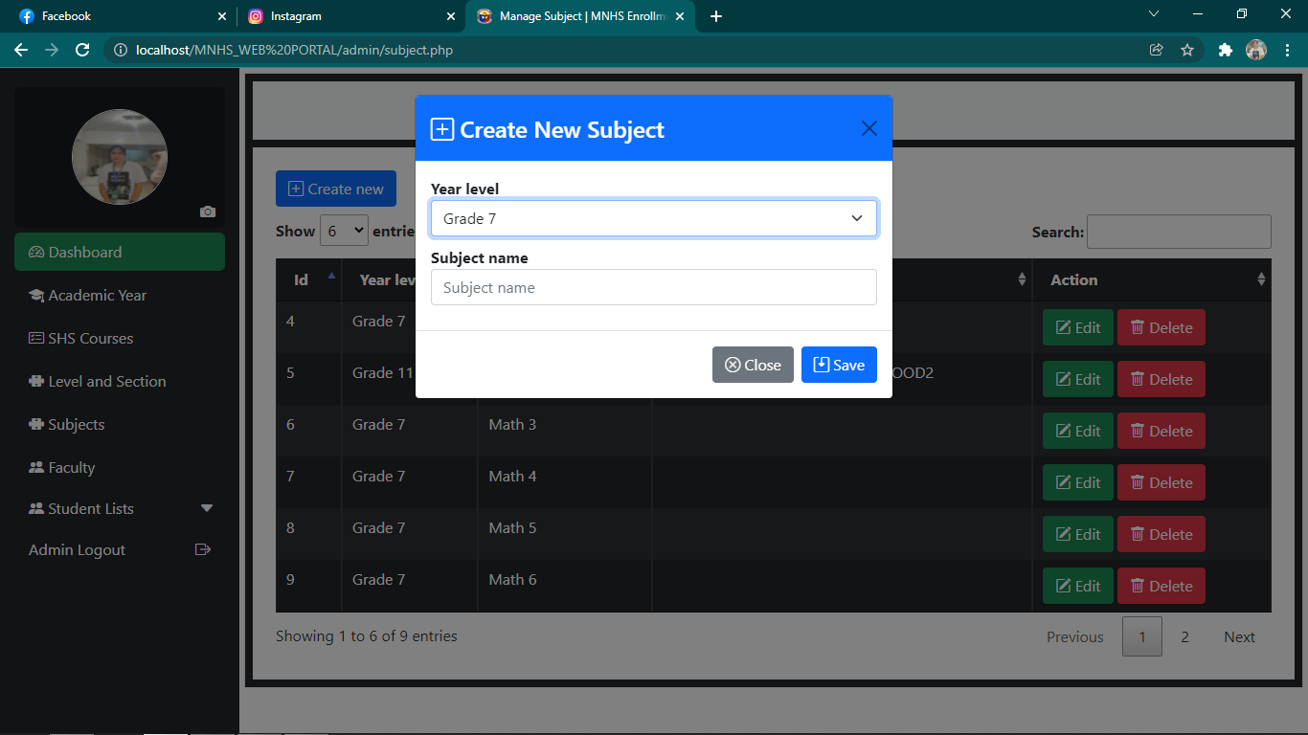

1

2

5

4

3

1. **Exit Button –** used to exit the form in creating new subject.

2. **Year Level –** dropdown button used to select grade level.

3. **Subject Name –** textbox used to input subject name.

4. **Close Button –** button used to close the form of creating new subject.

5. **Save button –** button used to save the newly created subject.

**Updating Subject**

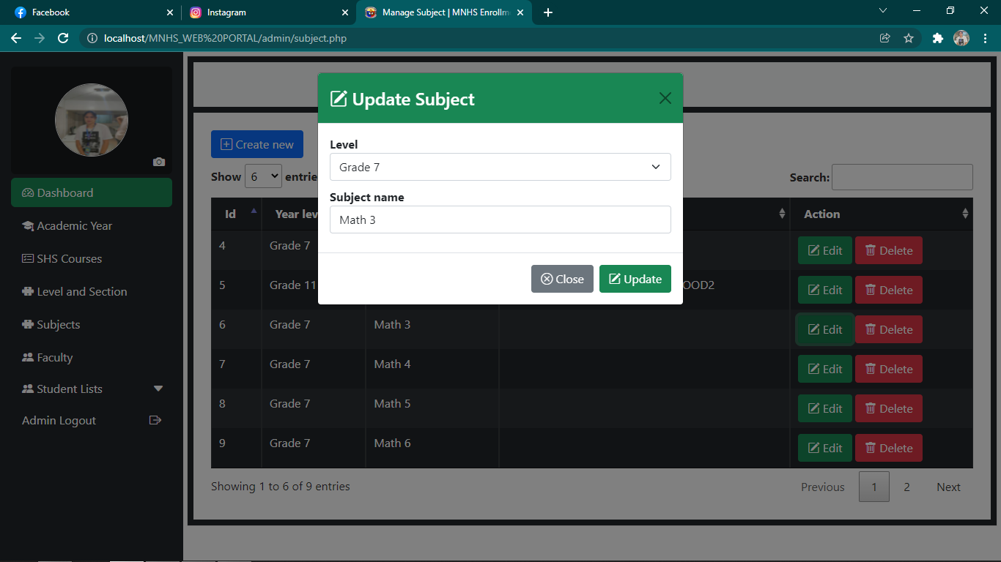

1

2

5

4

3

1. **Exit Button –** used to exit the form in updating subject.

2. **Level –** dropdown button used to select grade level.

3. **Subject Name –** textbox used to input subject name.

4. **Close Button –** button used to close the form of updating subject.

5. **Updating button –** button used to save the updated subject.

**Faculty Management**

5

6

4

1

2

3

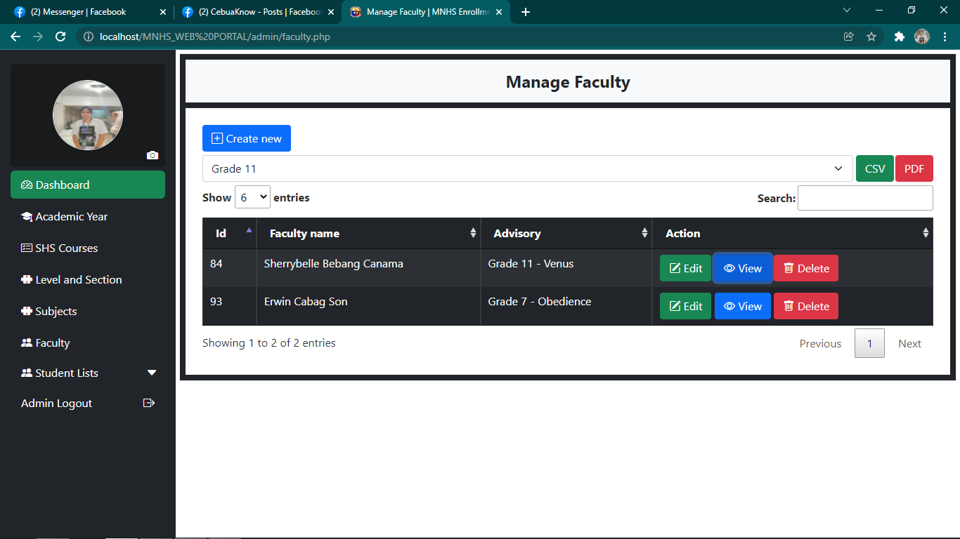

11

10

9

8

7

1. **Create New –** button used to add new faculty.

2**. Entries Filter –** button used to filter the number of faculties to be displayed.

3. **Grade level filter –** dropdown used to filter list of teachers by grade level for converting into excel or pdf.

4. **Search Bar** **–** used to search faculty.

5. **CSV Button –** button used to convert list into excel.

6. **PDF Button –** button used to convert list into pdf.

7. **Edit Button –** button used edit faculty’s information.

8. **View Button -** button used to view the faculty’s information.

9. **Delete Button -** button used to delete faculty.

10. **Previous Button –** button used to go back to previous page of the faculty management page.

11. **Next Button –** button used to go to the next page of the faculty management page.

**Creating New Faculty**

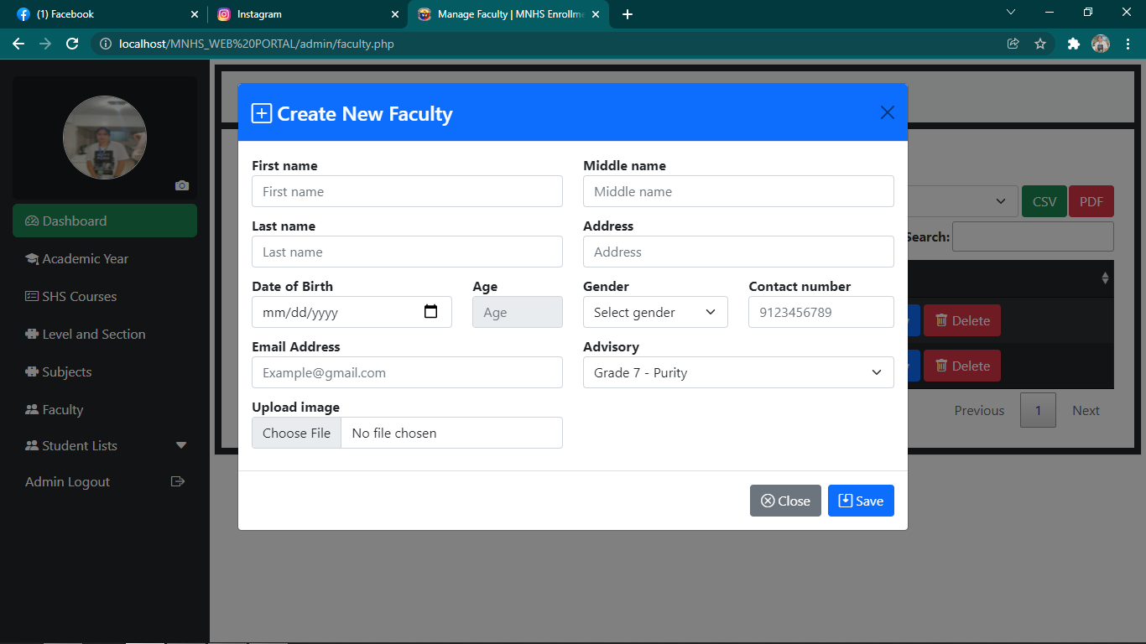

1

3

2

8

5

6

4

9

7

14

13

12

11

10

1. **Exit Button** – used to exit form in creating new faculty.

2. **First Name –** textbox used to input the faculty’s first name.

3. **Middle Name –** textbox used to input the faculty’s middle name.

4. **Last Name –** textbox used to input the faculty’s last name.

5. **Address –** textbox used to input faculty’s address.

6. **Date of Birth –** for inputing birthdate using calendar button.

7. **Age –** textbox for displaying auto-computed age of the faculty base from the date of birth.

8. **Gender –** dropdown button used to select gender.

9. **Contact Number –** textbox used to input faculty’s contact number.

10. **Email Address –** textbox used to input the faculty’s email address.

11. **Advisory –** dropdown button used to assign section of the faculty.

12. **Upload Image –** button used to assign photo for the faculty’s profile.

13. **Close Button –** used to close the form in creating new faculty.

14. **Save Button –** button used to save faculty’s information.

**Updating Faculty**

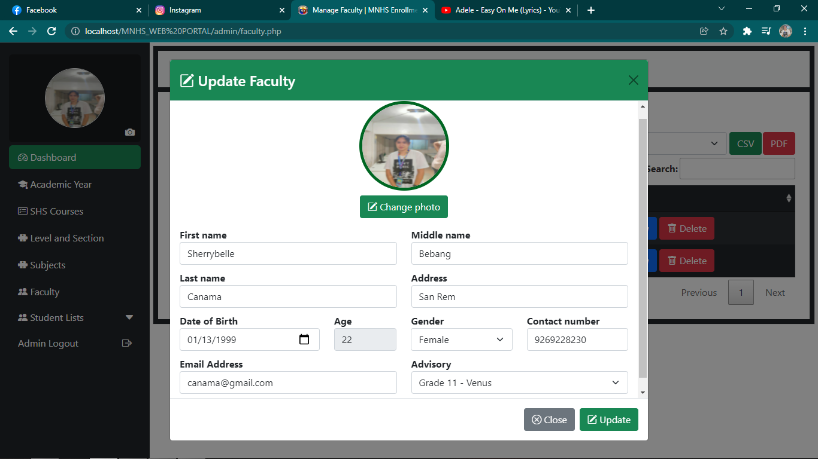

1

2

11

13

14

12

10

6

4

8

7

5

3

9

1. **Exit Button –** used to exit form in updating faculty’s information.

2. **Change Photo –** button used to choose photo for faculty’s profile.

3. **First Name –** textbox used to input changes in faculty’s first name.

4. **Middle Name –** textbox used to input changes in faculty’s middle name.

5. **Last Name –** textbox used to input changes in faculty’s last name.

5. **Address –** textbox used to input changes to faculty’s address.

6. **Date of Birth –** for inputing birthdate using calendar button.

7. **Age –** textbox for displaying auto-computed age of the faculty base from the date of birth.

8. **Gender –** dropdown button used to select gender.

9. **Contact Number –** textbox used to input faculty’s contact number.

10. **Email Address –** textbox used to input the faculty’s email address.

11. **Advisory –** dropdown button used to assign section of the faculty.

13. **Close Button –** used to close the form in updating faculty information.

14. **Update Button –** button used to save faculty’s information.

**Student’s Registration Management**

3

2

1

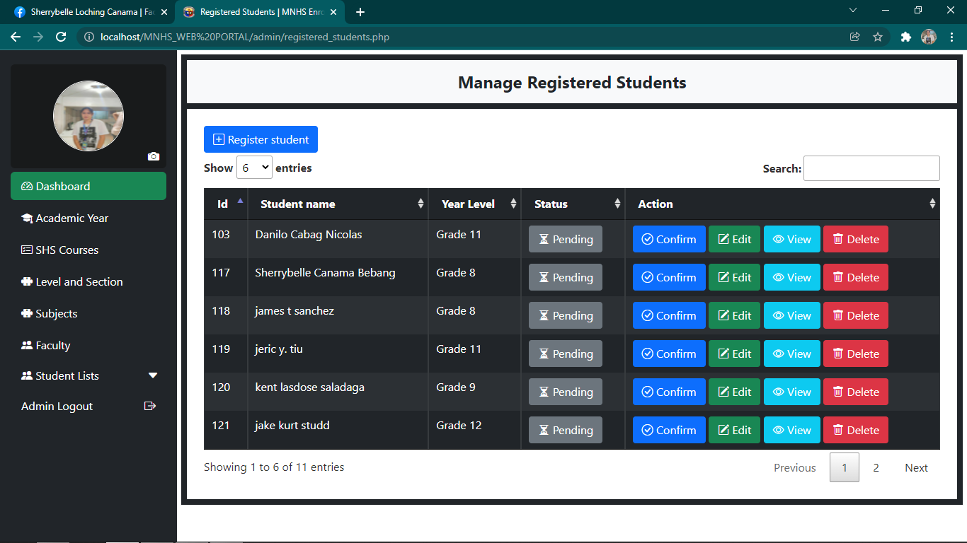

9

8

7

6

5

4

1. **Register Student –** button used to register new student.

2**. Filter –** button used to filter the number of students to display.

3. **Search Bar** **–** used to search student’s information.

4. **Confirm Button –** button used to confirm the student’s registration for enrollment.

5. **Edit Button -** button used to edit student’s information.

6. **View Button –** used to view student’s information.

7. **Previous Button –** button used to go back to previous page of the student’s registration page.

8. **Delete Button –** used to delete student’s information in the student’s registration page.

9. **Next Button –** button used to go to the next page of the student registration page.

**Confirming Student’s Enrollment**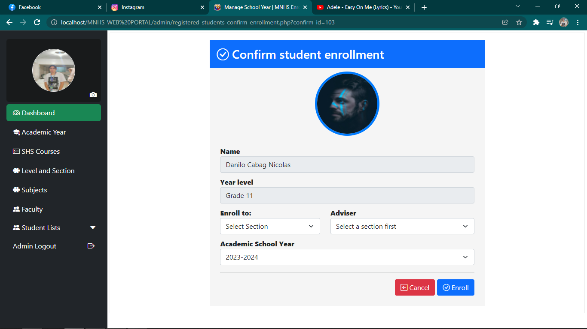

3

4

2

1

1. **Enroll to –** dropdown button for assigning section to the student.

2. **Adviser –** dropdown button for assigning adviser to the student.

3. **Enroll –** button used to confirm the enrollment of the student.

4. **Cancel Button –** button used to cancel the confirmation of enrollment of the student.

**Updating Student’s Information**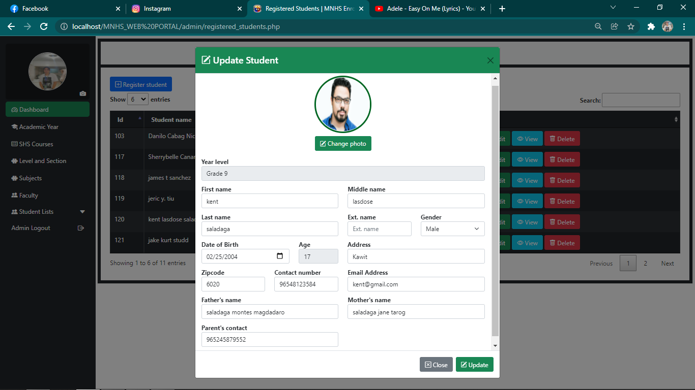

1

2

3

4

18

17

16

14

15

13

12

11

10

9

8

7

6

5

1. **Exit Button –** used to exit form in updating student’s information.

2. **Change Photo –** button used to choose photo for student’s profile.

3. **First Name –** textbox used to input changes in student’s first name.

4. **Middle Name –** textbox used to input changes in student’s middle name.

5. **Last Name –** textbox used to input changes in student’s last name.

6. **Extension Name –** textbox used to input changes in student’s extension name.

7. **Gender –** dropdown button used to select gender.

8. **Date of Birth –** for inputing birthdate using calendar button.

9. **Age –** textbox for displaying auto-computed age of the student, base from the date of birth.

10. **Address –** textbox used to input changes to student’s address.

11. **Zipcode –** textbox used to input changes to student’s zipcode.

12. **Contact Number –** textbox used to input student’s contact number.

13. **Email Address –** textbox used to input the student’s email address.

14. **Father’s Name –** textbox used to input changes in father’s last name.

15. **Mother’s Name –** textbox used to input changes in mother’s last name.

16. **Parent’s Contact Number –** textbox used to input parent’s contact number.

17. **Close Button –** used to close the form in updating faculty information.

18. **Update Button –** button used to save faculty’s information.

**Enrollment Management Page**

6

5

4

3

2

1

9

88

7

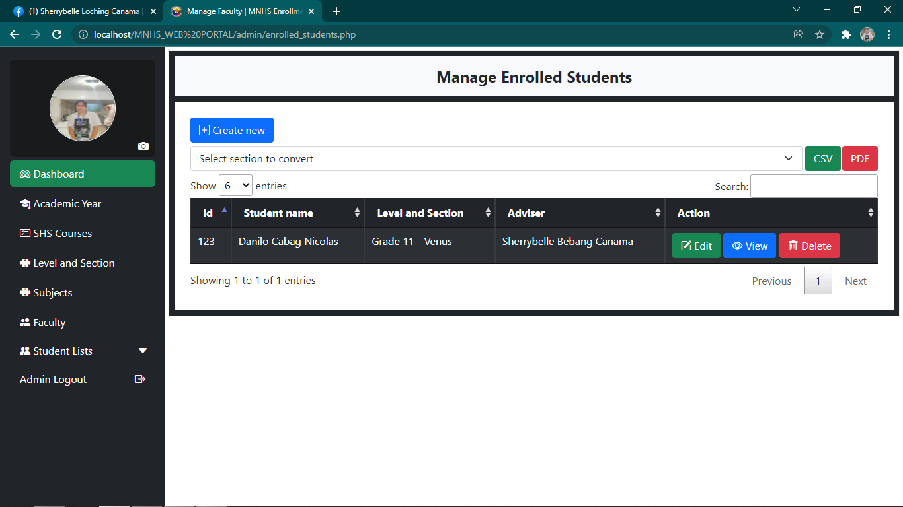

11

10

1. **Create New –** button used to add new student.

2**. Entries Filter –** button used to filter the number of students to be displayed.

3. **Grade level filter –** dropdown used to filter list of students to be displayed by grade level.

4. **Search Bar** **–** used to search enrolled student.

5. **CSV Button –** button used to convert list into excel.

6. **PDF Button –** button used to convert list into pdf.

7. **Edit Button –** button used edit student’s information.

8. **View Button -** button used to view the student’s information.

9. **Delete Button -** button used to delete student information.

10. **Previous Button –** button used to go back to previous page of the enrollment management page.

11. **Next Button –** button used to go to the next page of the enrollment management page.

**Updating Enrollment**

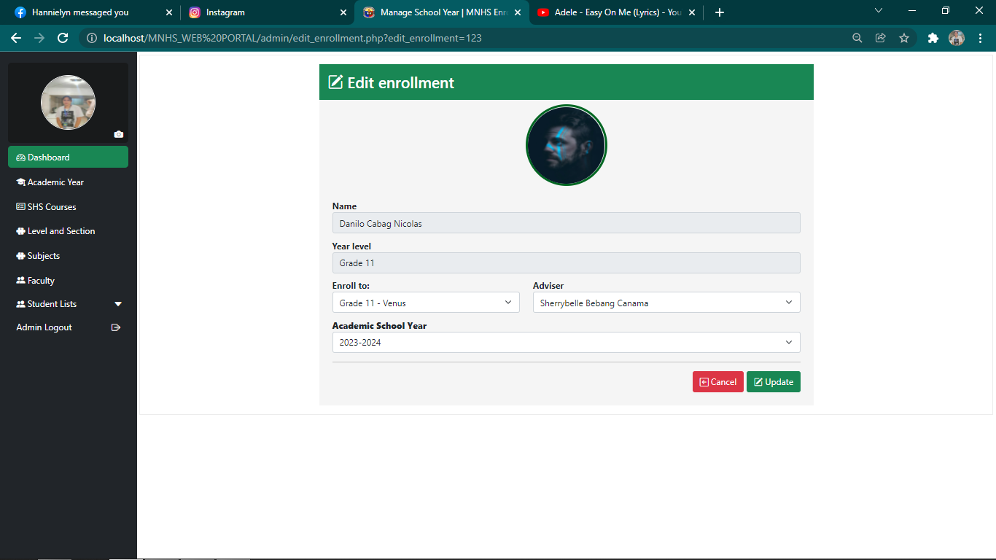

1

2

3

1. **Enroll to –** dropdown button for selecting section of the enrolled grade level.

2. **Update Button –** used to save changes of the student’s enrollment.

3.**Close Button –** used to close the form in updating student’s enrollment.

**Previous Enrollment Page**

**Figure**

3

1

2

5

4

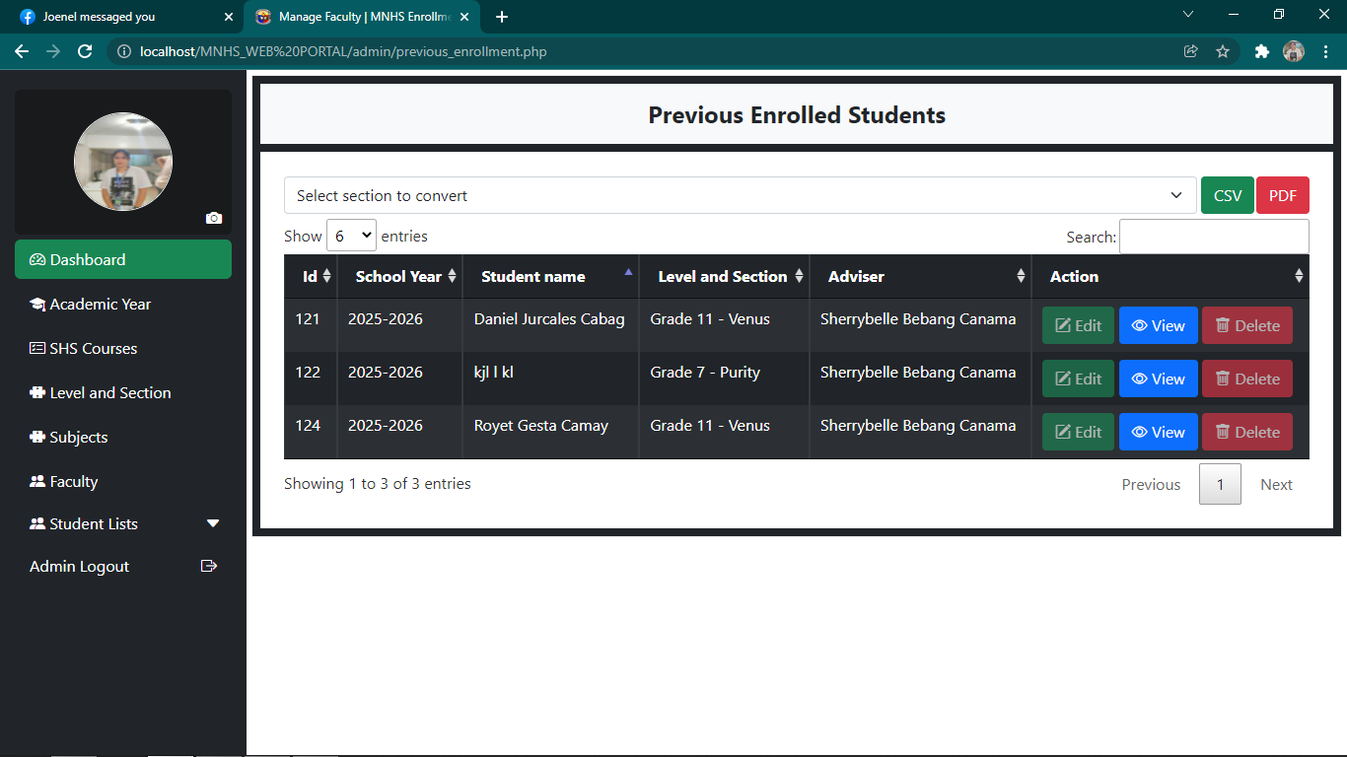

8

6

7

1**. Filter –** button used to filter the number of student’s information to display.

2. **Grade level filter –** dropdown used to filter list of students to be displayed by grade level.

3. **Search Bar** **–** used to search students from the previous enrollment.

4. **CSV Button –** button used to convert list into excel.

5. **PDF Button –** button used to convert list into pdf.

6. **View Button -** button used to view the student’s information in the previous enrollment.

7. **Previous Button –** button used to go back to previous page.

8. **Next Button –** button used to go to the next page.

**Admin Logout**

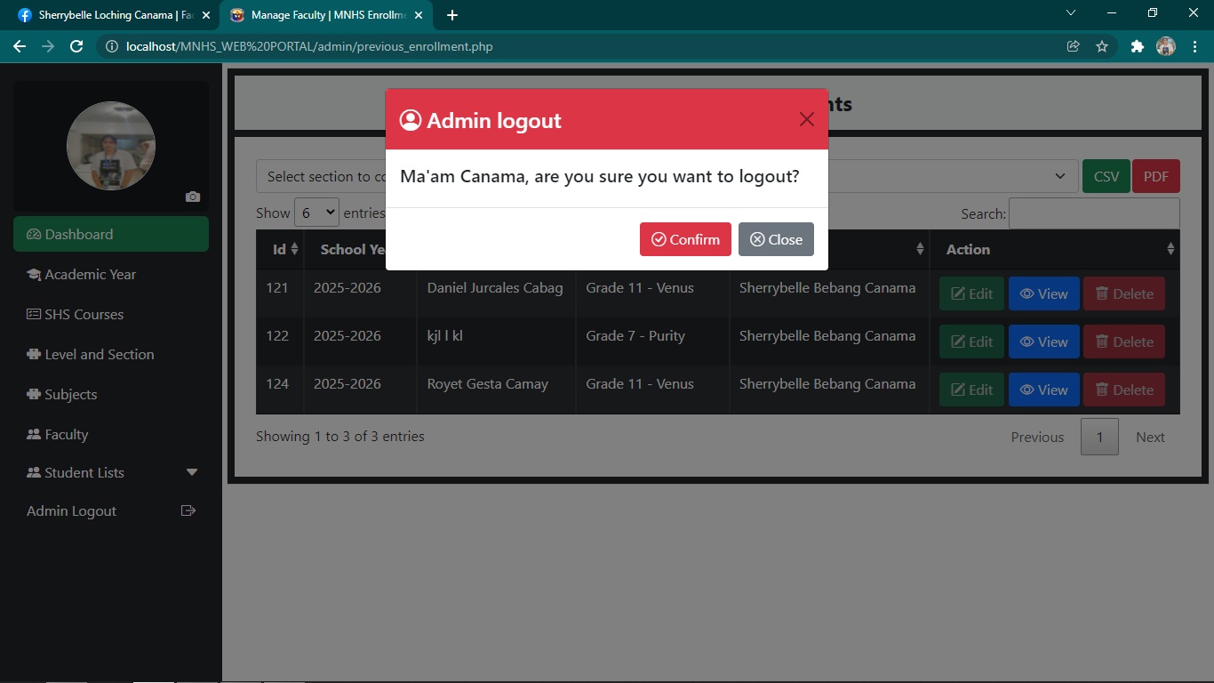

1

3

2

1. **Exit Button –** used to exit the admin logout form.

2. **Confirm Button –** used to confirm the logout session in the admin page.

3. **Close Button –** used to close the logout form.

**Student Homepage**

2

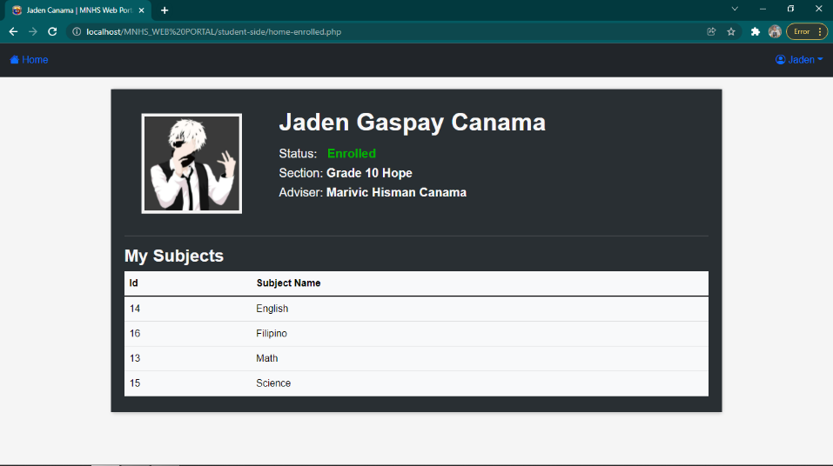

1

1. **Home –** button used to access the homepage of the student.

2. **Profile Button –** button used to view the profile or to log out account.

**View Profile**

2

1

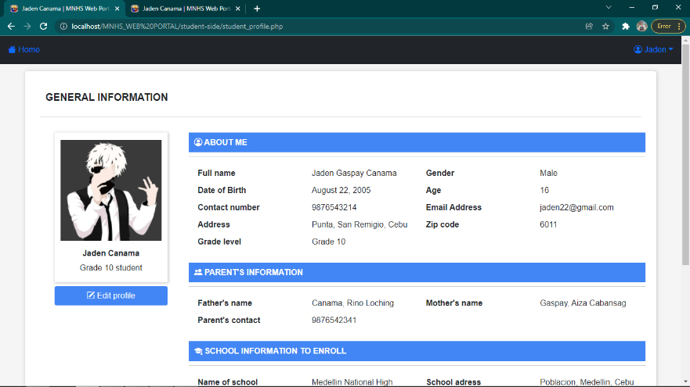

3

1. **Home –** button used to access the homepage of the student.

2. **Profile Button –** button used to view the profile or to log out account.

3. **Edit Profile –** button used to access the form in editing profile picture.

**Edit Profile**

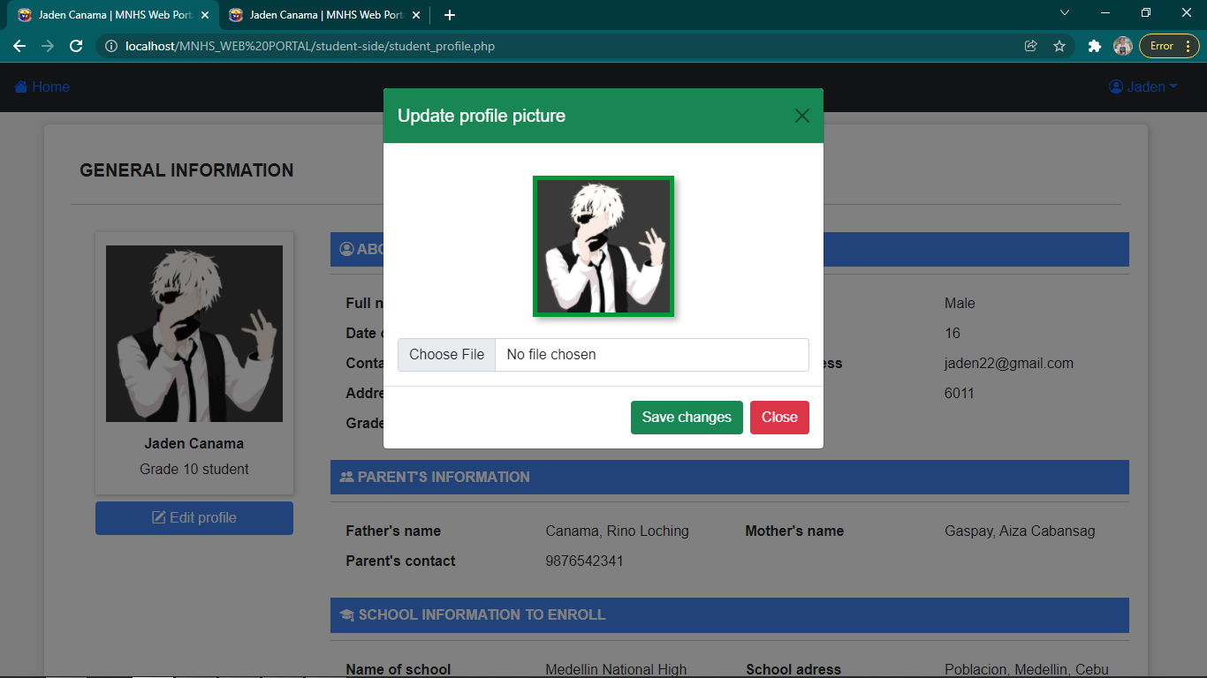

1

2

4

3

1. **Exit Button –** button used to exit form in editing profile picture.

2. **Choose File –** button used to choose profile picture from files.

3. **Save Changes –** button used to save the changes in profile picture.

4. **Close –** button used to close the form.

**Student Logout**

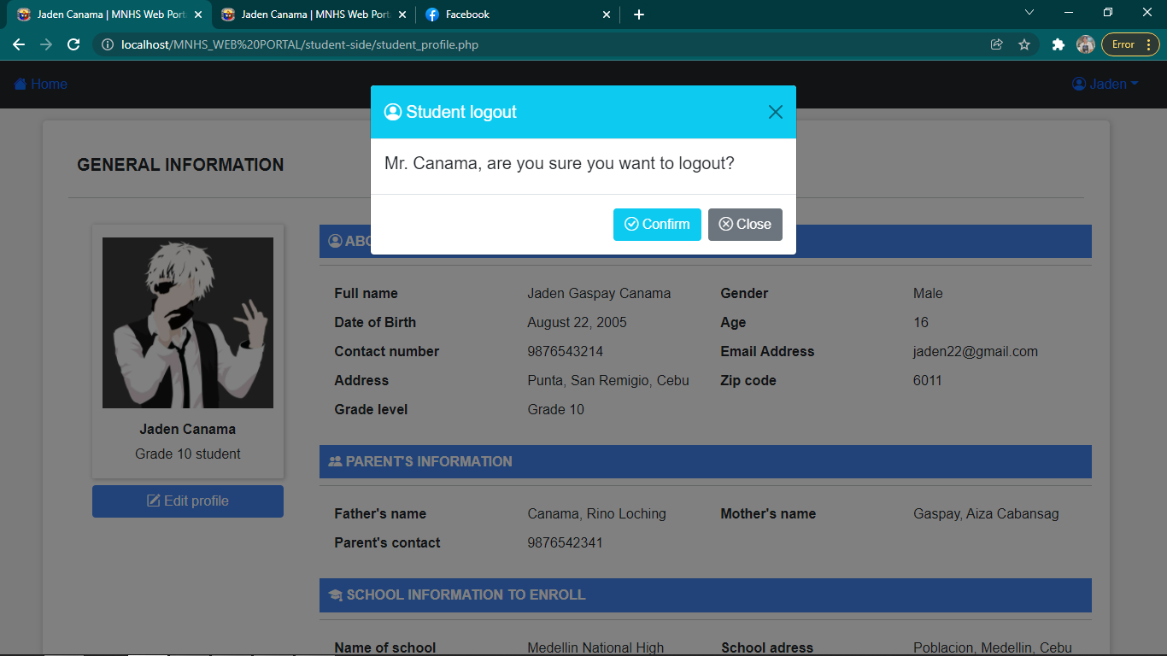

1

3

2

1. **Exit Button –** button used to exit student logout form.

2. **Confirm Button –** used to confirm the logout session in the student page.

3. **Close Button –** button used to close the student logout form.

**CHAPTER III**

**SUMMARY OF FINDINGS**

The researchers went through the planning process, conducted online survey, and gathered data through one on one interview with the principal and enrollment staff at Medellin National High School. Thus, found out that there is a need of online enrollment system in the school.

Based on the research and data gathered the researchers came up with the following results:

**Teachers of Medellin National High School:**

1. Most of the teachers sometimes misinterpret student's information due to student’s penmanship, and in viewing this sense, it can be stated that they find it hard to understand the handwriting of the students in their enrollment form.

2. Teachers sometimes lose or misplace students record.

3. Teachers agreed that it’s difficult to correct errors in student’s information using manual enrolment. Formal papers such as student's record must be kept neat and clean as much as possible.

4. Problem that was encountered by teachers during manual enrollment is that it takes long time to process manual enrollments.

5. Teachers find it hard to update the total number of enrollees manually.

6. Majority of the teachers said that they can easily find student’s record online.

7. Processing enrolments online is easier than doing it manually as agreed by the teachers.

8. Majority of the teachers answered that students or parents did not address any problems about the online registration.

9. The result establishes the fact that teachers are in favor of improving the current enrolment method.

10. Most of the teachers are in favor in adopting to our proposed system which is the Medellin National High School Online Enrollment System.

**Students of Medellin National High School:**

1. Most of the students agreed that they find it hassle to fill up forms using pen and paper because it really takes time to do it.

2 Coming over to Medellin Nation High School will lead cost to majority of the students due to different locations and some of them are far from the school so they have to travel just to enroll.

3. Greater number of student’s population agreed that filling out forms manually is time consuming.

4. Most of the students did not experience difficulties in getting enrollment forms while some of the students found it difficult to get forms.

5. As the respective advisers for every year level checks the enrollment forms of the students, some of it were lost due to places where the forms are hidden. But fortunately, majority of the students haven’t experienced losing their enrolment forms.

6. Online registration makes the enrollment faster as the majority of the students agreed with it.

7. Most of the students agreed that online registration lessens the money cost of enrolling to school.

8. Students have experienced problems in online registration.

9. Most of the students agreed that online registration is secured.

10. Students want the school to adopt online enrollment.

**CONCLUSIONS**

The researchers, we conclude that through the proposed system, the school can accommodate large number of students in a less time-consuming and more convenient way of registering and storing student records. This also gives the students the safety and comfort of registering their information online because they don’t need to come over to the school.

**RECOMMENDATIONS**

The researchers recommend that “Medellin National High School Online Enrollment System” should be implemented for easy access, more effective and a convenient way for a great satisfaction for both students and staff towards processing enrolment.

**To the staff**

The staff must be a computer literate and should be knowledgeable enough in handling student’s information.

**To the future researchers**

This study is an advocacy as a reference material to the other students who will conduct a research similar to this proposal. The researcher should upgrade, enhance our system and add more functionality that is not found in this proposed Online Enrollment.

**IMPLEMENTATION VIEW OF THE SYSTEM**

Implementation view of the systemis thetechnical representation of the system components that is required in implementing the activities and functions of the system.

**Component Diagram**

The component diagram is used to visualize the physical components in a system.



**USER**

**XAMPP**

**SOFTWARE APPLICATION**

**SUBLIME TEXT**3

**Figure 7**

**Component Diagram**



**PC/HOST**

**Deployment Diagram**

The deployment diagram is utilized to illustrate the design of run-time procedures, events and processes that are placed on them.

APPLICATION

Sublime Text

DATA

XAMPP

SECURITY

Antivirus

**Figure 8**

**Deployment Diagram**

**COST-BENEFITS ANALYSIS**

This chapter focuses on the analysis of the cost and its benefits in investing in a new system.

The development cost was established through a personal interview with the administration and staff of Medellin National High School.

1. **Development Cost of the System**

**Hardware:**

1. Laptop = Php 23, 000.00
2. Printer Unit (Epson) with scanner = Php 7, 945.00

**Total = Php 30, 945.00**

**Software:**

OS (Windows 10) = Php 1, 500.00

Smadav (Anti-virus) 2019 = Php 1, 400.00

Sublime Text = Php 2,500.00

**Total Software Cost = Php 5, 400.00**

**Total Development Cost = Php 31, 400.00**

**BIBLIOGRAPHY**

Agdeppa, A., Baldemoral, K., & Eugerio, J. (n.d.). *Computerized Enrollment*. Retrieved from PDFCOFFEE: https://pdfcoffee.com/computerized-enrollment-5-pdf-free.html

Binayao, K. T., Leonar, R. J., Lucas, J. R., & Puertas, J. J. (2012, October). *Online Enrollment System of Liceo de Cagayan University.* Retrieved from Research Gate: https://www.researchgate.net/publication/270835359_Online_Enrollment_System_of_Liceo_de_Cagayan_University

Custinar, A., Cruz, C. J., Ecobiza, T., & Jane, P. M. (2015, March 27). *Computerized Enrollment System for Mary Lourdes Academy.* Retrieved from Academia: https://www.academia.edu/12481820/Computerized_Enrollment_System_for_Mary_Lourdes_Academy

Kasser, J., & Williams, V. (1999). *The student enrollment and course tracking system Meta-Project*. Retrieved from IEEE Xplore: https://ieeexplore.ieee.org/abstract/document/807779

Mariel, B., & Esmeralda, R. (2009, May). *Online Enrollment System For Cavite Maritime Institute DasmariÑas, Cavite.* Retrieved from SCRIBD: https://www.scribd.com/doc/21592392/Online-Enrollment-System-for-Cavite-Maritime-Institute-DasmariNas-Cavite#scribd

**APPENDICES**

**APPENDIX A**

**ENDORSEMENT LETTER**

**CEBU ROOSEVELT MEMORIAL COLLEGES**

San Vicente St., Bogo City, Cebu

**College of Computer Studies**

July 5, 2021

**ELIZABETH D. ARREGLO**

Principal

Medellin National High School

Dear Ma'am/Sir:

As one of the requirements for our degree program, we, the researchers of Cebu Roosevelt Memorial Colleges taking up Bachelor of Science and Information Technology, have proposed a system study entitled "**Medellin National High School Online Enrollment System**" which was approved by Ms. Marjorie Reso, our adviser and Dr. Jonel Rhey D. Gelig, our dean of College of Computer Studies.

We, the researchers, are asking permission from your good office to allow us to conduct an interview about the transaction process and other relevant information about this matter. We assure you that this study in creating a system will help the school, Medellin National High School to be more effective in dealing transactions. We are hoping for your full support and cooperation to make this possible.

We assure you that the important data that will be gathered during the interview will be treated confidential.

We look forward to your positive and favorable response.

Thank you and God bless!

Respectfully yours,

**SON, ERWIN OLIVAR, ANJIE LOU Y.**

RESEARCHER RESEARCHER

**CANAMA, SHERRYBELLE L.**

RESEARCHER

Noted by: Approved by:

**MS. MARJORIE RESO DR. JONEL RHEY D. GELIG**

Adviser Dean, College of Computer Studies

**APPENDIX B**

**SURVEY QUESTIONNAIRES FOR TEACHERS**

**Objectives:** The objectives of this survey are to find out the common possible problems of the organization regarding to its process of enrolment so that the researchers can implement a more convenient system that would lessen the problems for the organization to encounter in the future with the help of “**Medellin National High School Online Enrollment System**”.

**Directions:** Read each question carefully and check the boxes that answers the given questions.

1. In processing enrolments manually, have you experienced misinterpreting student’s written information?

Always

Sometimes

Never

25

1. Have you experienced losing or misplacing student’s records?

Always

Sometimes

Never

1. Do you find it difficult to correct the errors in the student’s enrolment form using manual enrolment process?

Strongly Agree

Disagree11

Strongly Disagree

Agree

1. As you use the traditional or the manual method of enrolment, what are the common problems you have experienced and encountered?

Redundant process of the student’s enrolment

Inaccurate input of student’s information

Takes long time to process

Others, please specify___________________________________.

All of the above

5.Is it hard for you to get or update the total number of enrollees you processed manually?

Yes

No

6.Is it easier to find the student’s record online than doing it manually?

Yes

No

7. As you administer enrollees, do you think it is easier to process enrolments online?

Strongly Agree

Disagree

Strongly Disagree

Agree

8. Does the students or parents addressed any problems with regards to registering online?

Yes

No

9. Are you willing to improve your current enrolment method for a better one?

Strongly Agree

Disagree

Strongly Disagree4

Agree

10. Are you willing to adopt to a new and convenient way in processing your enrollment?

Strongly Agree

Disagree

Strongly Disagree

Agree

**SURVEY QUESTIONNAIRES FOR STUDENTS**

**Objectives:** The objectives of this survey are to find out the common possible problems of the organization regarding to its process of enrolment so that the researchers can implement a more convenient system that would lessen the problems for the organization to encounter in the future with the help of “**Medellin National High School Online Enrollment System**”.

**Directions:** Read each statement carefully and check the box that answers the given questions.

1. During the enrolment process, is it hassle for you to fill out forms manually?

Strongly Agree5

Disagree

Strongly Disagree

Agree

1. Is it costly for you to come over to Medellin National High School just to enroll?

Strongly Agree

Disagree1

Strongly Disagree

Agree

1. As you fill out forms manually, is it time consuming?

Strongly Agree

Disagree

Strongly Disagree

Agree

4. During the manual enrolment process, do you find it difficult to get enrolment forms?

Strongly Agree

Disagree

Strongly Disagree

Agree

5. Have you experienced losing your enrolment form?

Yes

No

28

6. Does using online registration makes the enrollment faster?

Strongly Agree

Disagree

Strongly Disagree

Agree

7. Online registration lessens money cost upon enrolling at school.

Strongly Agree

Disagree

Strongly Disagree

Agree

8. Have you experienced problems in registering online?

Yes

No

9. Do you think registering online is secured?

Strongly Agree

Disagree

Strongly Disagree

Agree

10. Do you wish for Medellin National High School to have an own online enrollment system where you register online?

Strongly Agree

Disagree

Strongly Disagree

Agree

**Appendix C**

**Work Breakdown Structure**

Work breakdown structure includes the start and completion dates for all tasks, activities, and deliverables defined.

|  |  |  |  |  |  |
| --- | --- | --- | --- | --- | --- |
| **Task Name** | **Start Date** | **Finish Date** | **Duration (Days)** | **Persons Involved** | **Predecessor Task** |
| **Project Planning Phase** | 06/28/21 | 07/25/21 | 11 Days | A, B, C |  |
| 1.1 Define the problem | 06/28/21 | 06/29/21 | 2 Days | A, B, C |  |
| 1.2 Produce project schedule | 06/29/21 | 06/29/21 | 1 Day | A, B, C | 1.1 |
| 1.3 Confirm project feasibility | 06/30/21 | 07/05/21 | 6 Days | A, B, C | 1.2 |
| 1.4 Staff the project | 07/06/21 | 07/06/21 | 1 Day | A, B, C | 1.3 |
| 1.5 Launch the project | 07/25/21 | 07/25/21 | 1 Day | A, B, C | 1.4 |
| **Analysis phase** | 07/26/21 | 08/16/21 | 24 Days | A, B, C |  |
| 2.1 Gathering the information | 07/26/21 | 07/30/21 | 5 Days | A, B, C | 1.5 |
| 2.2 Defining the system requirements | 07/31/21 | 08/01/21 | 2 Days | A, B | 2.1 |
| 2.3 Build prototypes for discovery of requirements | 08/01/21 | 08/11/21 | 12 Days | A | 2.2 |
| 2.4 Generate and evaluate alternatives | 08/12/21 | 08/14/21 | 3 Days | A, B, C | 2.3 |
| 2.5 Review recommendation with management | 08/15/21 | 08/16/21 | 2 Days | A, B, C | 2.4 |
| **Design Phase** | 10/01/12 | 11/08/21 | 40 Days | A, B, C |  |
| 3.1 Design and Integrate the Networks | 10/01/21 | 10/02/21 | 3 Days | A, B, C | 2.5 |
| 3.2 Design the Application Structures | 10/03/21 | 10/06/21 | 4 Days | A, B, C | 3.1 |
| 3.3 Design User Interfaces | 10/07/21 | 10/21/21 | 15 Days | A, B, C | 3.2 |
| 3.4 Design and Integrate the database | 10/22/21 | 10/29/21 | 8 Days | A, B, C | 3.3 |
| 3.5 Prototype for Details | 10/30/21 | 11/05/21 | 6 Days | A, B, C | 3.4 |
| 3.6 Design and System Control | 11/05/21 | 11/08/21 | 4 Days | A, B, C | 3.5 |
| **Implementation phase** | 11/09/21 | 11/14/21 | 6 Days | A, B, C |  |
| 4.1 Construct the Software Components | 11/15/21 | 11/16/21 | 2 Days | A, B, C | 3.6 |
| 4.2 Verify and Test | 11/17/21 | 11/17/21 | 1 Day | A, B, C | 4.1 |
| 4.3 Install the User Convert Data | 11/18/21 | 11/18/21 | 1 Day | A, B, C | 4.2 |
| 4.4 Train User | 11/22/21 | 11/22/21 | 1 Day | A, B, C | 4.3 |
| 4.5 Install the System | 11/23/21 | 11/23/21 | 1 Day | A, B, C | 4.4 |

Legend:

A - Erwin Son

B - Sherrybelle Canama

C - Anjielou Olivar

**Table 41**

**Work Breakdown Structure**

**Appendix D**

**GANTT CHART**

Gantt Chart in which a series of horizontal lines shows the amount of work done or production completed in certain periods of time in relation to the amount planned for those periods.

**Figure 9**

**Gantt Chart**

**APPENDIX E**

**RELEVANT SOURCE CODE**

**HOME PAGE FORM**

**<?php**

**session_start();**

**include 'header.php';**

?>

<style>

#container {

margin-top: 54px;

width: auto;

}

.school-text{

font-size: 45px;

margin: 20px 0 -20px 30px;

}

.big-text {

font-size: 52px;

color: darkorange;

margin: 20px 0 20px 30px;

}

.small-text {

font-size: 45px;

color: darkred;

margin: -25px 0 10px 30px;

}

#enroll {

position: relative;

z-index: 3;

background-color: darkorange;

color: #fff;

margin: 20px 0 20px 30px;

width: 150px;

padding: 10px;

border-radius: 20px;

box-shadow: 1px 1px 3px #999;

transition: .3s

}

#enroll:hover{

background-color: transparent;

color: darkorange;

border: 1px solid darkorange;

box-shadow: 5px 5px 10px #999;

}

.banner-info .paragraph{

margin: -10px 0 20px 30px;

}

.banner-image {

padding-top: 35px;

}

.banner-image img {

height: 580px;

display: block;

margin: auto;

}

@media only screen and (max-width : 349px) {

.school-text{

font-size: 30px;

margin: -20px -20px;

}

.big-text {

font-size: 27px;

margin: 15px -20px;

}

.small-text {

margin: -20px -20px;

font-size: 25px;

}

.banner-info .paragraph{

margin: 20px -20px;

font-size: 14px;

}

#enroll{

position: relative;

z-index: 3;

margin: 15px -20px;

width: 140px;

padding: 7px;

}

.banner-image img{

margin-top: -65px;

margin-right: 5px;

height: 310px;

}

}

@media only screen and (min-width : 350px) and (max-width : 480px){

.school-text{

font-size: 35px;

margin: -30px -30px;

}

.big-text {

font-size: 32px;

margin: 18px -30px;

}

.small-text {

margin: -30px -30px;

font-size: 30px;

}

.banner-info .paragraph{

margin: 25px -30px;

}

#enroll {

position: relative;

z-index: 3;

margin: 35px -30px;

width: 140px;

padding: 7px;

}

.banner-image img{

margin-top: -210px;

margin-right: 5px;

height: 437px;

}

}

@media screen and (min-width: 481px) and (max-width: 768px) {

.school-text{

font-size: 45px;

margin: -10px -20px;

}

.big-text {

margin: -10px -20px;

font-size: 42px;

}

.small-text {

margin: -10px -20px;

font-size: 40px;

}

.banner-info .paragraph{

margin: 10px -20px;

}

#enroll {

position: relative;

z-index: 3;

margin: 40px -20px;

position: absolute;

}

.banner-image img{

margin-top: -100px;

margin-right: 5px;

height: 450px;

}

}

@media screen and (min-width: 769px) and (max-width: 960px) {

.content {

padding: 0;

}

.school-text{

font-size: 45px;

margin: -10px -20px;

}

.big-text {

margin: -10px -20px;

font-size: 42px;

}

.small-text {

font-size: 40px;

margin: 10px -20px;

}

.banner-info .paragraph{

margin: -10px -20px;

}

#enroll {

position: relative;

z-index: 3;

margin: 60px -20px;

position: absolute;

}

.banner-image img{

margin-top: 30px;

margin-left: -100px;

height: 590px;

}

}

</style>

<div class="container-fluid mb-5 bg-light" id="container">

<div class="row">

<div class="col-12 col-sm-12 col-md-6 col-lg-6 banner-info p-5 content">

<h1 class="school-text"><strong>SCHOOL</strong></h1>

<p class="big-text"><strong>ADMISSION</strong></p>

<p class="small-text"><strong>OPEN NOW</strong></p>

<p class="paragraph">Another school year is about to start and we can't wait to meet our new set of students and enjoy learning with us!</p>

<a href="" class="btn" data-bs-toggle="modal" data-bs-target="#register_student" id="enroll"><strong>Enroll Now</strong></a>

</div>

<div class="col-12 col-sm-12 col-md-6 col-lg-6 banner-image content">

<img src="images/enroll.png" class="img-responsive">

</div>

</div>

</div>

<?php include 'admission.php'; ?>

</body>

<?php include 'footer.php'; ?>

**</html>**

**APPENDIX F**

**CURRICULUM VITAE**

**Erwin Son**

Purok San Isidro, Daanlungsod, Medellin, Cebu

09359428963

Sonerwin12@gmail.com

# **Professional Profile**

I can lead a team and work under pressure. My objective is to impart my knowledge and computer related skills to the company as I am studying an IT course and I am very good at communication skills.

# **Core Skills & Achievements**

|  |  |
| --- | --- |
| Photo and Video Editor | Consistent Honor in Elementary |
| Front-End Web Developer | Consistent Honor in High School |
| Modulo Art Champion | Attended Leadership Seminars |

# **Education**

|  |  |  |
| --- | --- | --- |
| 2018 - 2022 | : | Bachelor of Science in Information Technology  Cebu Roosevelt Memorial Colleges  San Vicente St., Bogo City, Cebu |
| 2012 - 2018 | : | Medellin National High School |
|  |  | Poblacion, Medellin, Cebu |
| 2006 - 2012 | : | Medellin Central School |
|  |  | Poblacion, Medellin, Cebu |

# **References**

**JHONDEN LUNA**

ICT Teacher

Medellin National High School

Poblacion, Medellin, Cebu

09269228230

**AILEEN TORREVILLAS**

ICT Teacher

Medellin National High School

Poblacion, Medellin, Cebu

09686382235

**Anjie Lou Olivar**

Cayang, Bogo City, Cebu

09559964061

kuysjelo@gmail.com

# **Professional Profile**

I graduated with a Bachelor of Science in Information Technology. My objective of applying for the position is to utilize my training and skills, while making a significant success to your company. I am flexible, can multi-task, can work under pressure and a hard-working student assistant.

# **Core Skills & Achievements**

|  |  |
| --- | --- |
| Photoshop | Encoder |
| Video Editor | Photocopy Machine |
| ID Maker | Sociable |

# **Education**

|  |  |  |
| --- | --- | --- |
| 2021-2022 | : | Bachelor of Science in Information Technology  Cebu Roosevelt Memorial Colleges  San Vicente St., Bogo City, Cebu |
| 2017-2018 | : | City of Bogo Science and Arts Academy (CBSAA) |
|  |  | Cogon, Bogo City, Cebu |
| 2006-2012 | : | Cayang Elementary School |
|  |  | Cayang, Bogo City, Cebu |

# **References**

**DR. JONEL GELIG**

CCS Dean

Cebu Roosevelt Memorial Colleges

San Vicente St., Bogo City, Cebu

0977-842-4200

**MR. JACINTO ANTONIO LEPITEN JR.**

Property Costudian Purchaser

Cebu Roosevelt Memorial Colleges

San Vicente St., Bogo City, Cebu

0967-012-7747

**Sherrybelle Canama**

Gairan, Bogo City, Cebu

09205183966

canamasherry@gmail.com

# **Professional Profile**

I can work in a team environment and I am flexible. My objective is to impart my skills and knowledge in technology related work and at the same time learn from the company.

# **Core Skills & Achievements**

|  |  |
| --- | --- |
| Front end programmer | Certified technopreneur |
| Photo and Video Editor | Consistent Honor |
| Good in communication | Completed work immersion |

# **Education**

|  |  |  |
| --- | --- | --- |
| 2018-2022 | : | Bachelor of Science in Information Technology  Cebu Roosevelt Memorial Colleges  San Vicente St., Bogo City, Cebu |
| 2012-2018 | : | San Remigio National High School |
|  |  | Poblacion, San Remigio, Cebu |
| 2006-2012 | : | Punta Elementary School  Punta, San Remigo, Cebu |

# **References**

**DIANA LYNN FERNANDEZ**

Immersion Adviser

San Remigio National High School

San Remigio, Cebu

09352442183

**VICTOR SINANGOTE**

ICT Teacher

San Remigio National High School

San Remigio, Cebu

09380576021

1. Mariel Bacala and Esmeralda Reaño, *Online Enrolment System for Cavite Maritime Institute Dasmariñas, Cavite: Enrollment System*(Dasmariñas Cavite:jctoinks,2009), 5

   <http://www.scribd.com/doc/21592392/Online-Enrollment-System-for-Cavite-Maritime-Institute-DasmariNas-Cavite#scribd>
2. Joseph Kasser, *The student enrollment and course tracking system* (National University ogSingapore:ieeexplore.ieee.org,Jan 1 1999)

   <https://www.academia.edu/949714/The_student_enrollment_and_course_tracking_system_Meta_Project>
3. Krishia Binayao, Jennyliz Lucas, Rahanee Jane Leonar and Jenky Jane Puertas, *Online Enrollment System of Liceo de Cagayan University*

   https://www.researchgate.net/publication/270835359_Online_Enrollment_System_of_Liceo_de_Cagayan_University
4. Custinar, Abigaile, Cruz, Christopher Jaycee, Ecobiza, Themarie, and Piquero, Mery Jane, *Computerized Enrollment System,* 8

   https://www.academia.edu/12481820/Computerized_Enrollment_System_for_Mary_Lourdes_Academy
5. Acel P. Agdeppa, Karl A. Baldelomar, Blakewyn Borres, and Jeremy A. Eugerio*, Enrollment System for St. Jude Parish School*

   https://pdfcoffee.com/computerized-enrollment-5-pdf-free.html